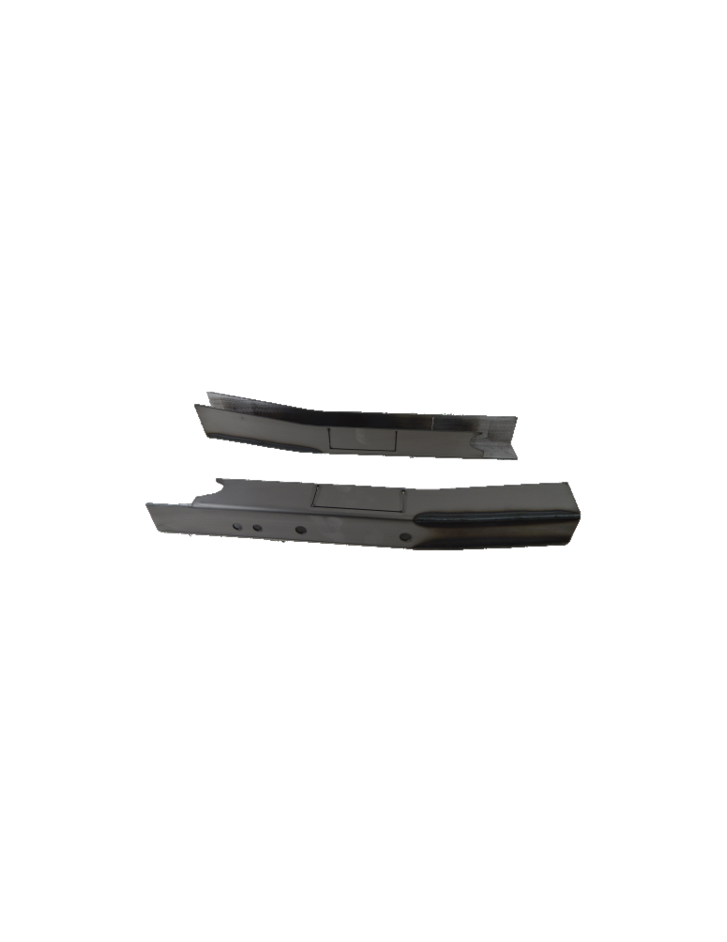 **Installation Instructions**

ART-221

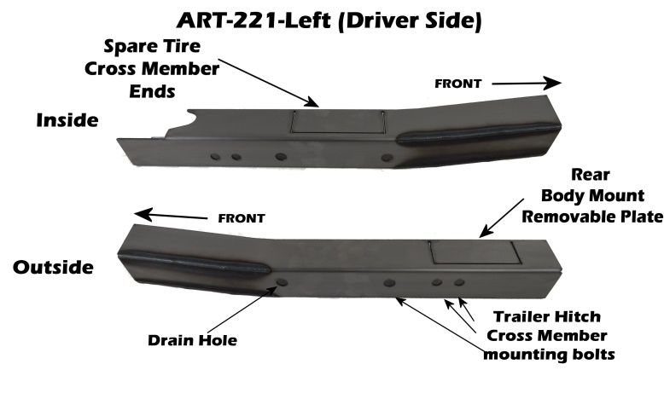**IMPORTANT: Read and understand the “General Instructions for Installing SafeTCap Frame Repair Kits” before you begin.**

1. Jack up the rear of vehicle and support the frame on jack stands. Make sure the rear of vehicle is fully accessible.
2. Remove the rear wheels and lower the spare tire, also remove the trailer hitch cross member from each side of the frame, if equipped.

Figure 1

1. 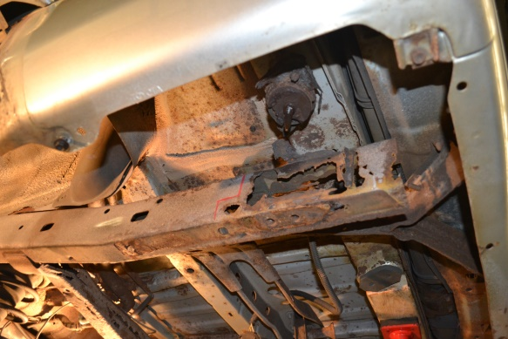We’ve designed our ART-221 to repair the rear frame regardless of severity of degradation and rust, as long as at least ½” - ¾” of the top of the frame is capable of being welded.

Pic 1

1. If you are repairing both sides, **cut & repair one side at a time** keeping one side assembled as a reference/measuring point.
2. Determine whether you will need to remove or splice the rear body mount from the frame or if you will remove the corresponding notch plate from the ART-221(**See Pic 1**). Also for the spare tire cross member.
3. 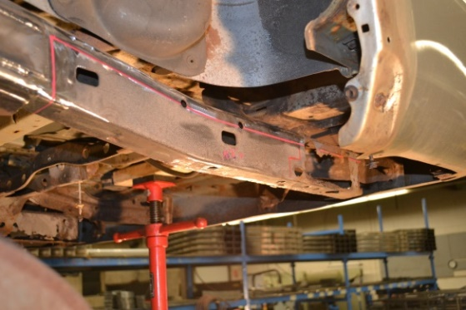Slide ART-221 up onto the frame from underneath until there is no gap between the bottom of original frame. Then outline the ART-221 with a paint marker or sharpie. **(See Pic 2)**

Pic 2

1. Remove the frame kit, then, grind the frame down to clean metal along the entire marked line. Remove any rust within the marked outline, and also remove the bottom of the original frame.
2. 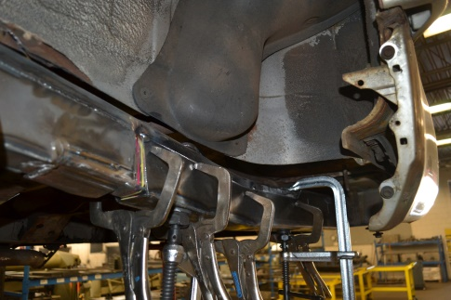Clamp the ART-221 firmly against the original frame ensuring there is no gaps along the edges.
3. Tackweld the ART-221 to the frame at the corners, then every 4” to 6” along the entire upper edges, Then remove the clamps.
4. 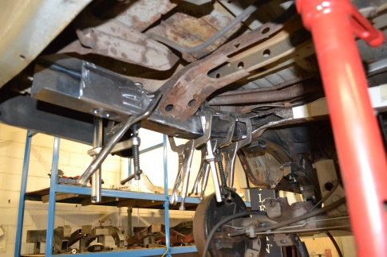 Check fitment, then weld the frame kit to the original frame. Alternate welds so you are not heating any one area too much.
5. If you notched the body mount and/or cross member make sure to weld the perforated cut lines for each removable plate, and also weld the cross member to the ART-221 and body mount.
6. 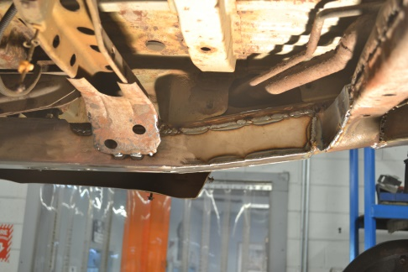Check measurements and door gaps to make sure the vehicle has stayed straight, then, weld all edges 100%.
7. Prime and/or paint the repaired area, then re-attach any brackets, wiring and/or brake lines back to the frame and make sure to secure them.

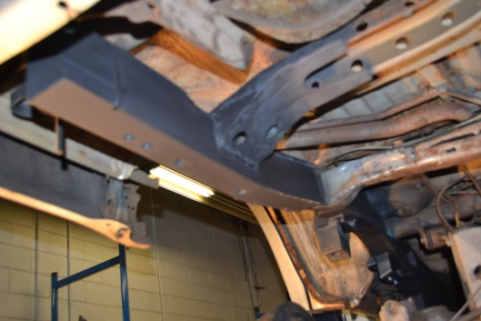

**Finished**

**We make the Kits, that Fit!**

**Note:** Pictures in this installation instruction sheet are for demonstration purposes only and may not actually reflect the identical make, model and year of the vehicle you are working on.