ART-243 Mid/Rear Frame Section Toyota Tundra 2000 - 2006
ART-243 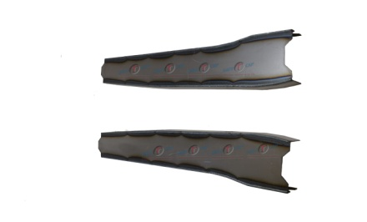
Installation Instructions
IMPORTANT: Read and understand the “General Instructions for Installing SafeTCap® Frame Repair Kits” before you begin. Disconnect the negative battery terminal or remove the battery from vehicle before welding to the frame of the vehicle.
- Jack up the rear of vehicle and support the frame on properly rated jack stands so the rear axle hangs free and suspension is unloaded. Make sure the area above the rear axle is fully accessible.
- If you are repairing both sides, cut & repair one side at a time keeping one side assembled as a reference/measuring point.
- Remove fuel tank and safely store at least 20ft away from the work area and protect it from any cutting, grinding, or welding sparks by wrapping it in a fire proof blanket.
- Support the rear axle with a Hyd. Jack and disconnect both Driver and Passenger side shocks from the frame. Inspect each shock and the rubber boots, replace if necessary.
- To install the ART-243, you don’t need to remove the bed from the vehicle, it helps to leave the bed bolted onto the frame as it will ensure the frame doesn’t twist or bend during the repair.
- Measure the bump stop and note its location. Carefully remove the rivets holding it to the frame, try not to destroy the bump stop during removal, you will need to reinstall it after the ART-243 is welded on.
- Slide the ART-243 over the frame from the outside. Then, Mark the original frame with a sharpie or soapstone.
- Prep the repair area for welding by grinding the frame down to clean, bare metal along the marked outline on both the outer, and underside of the frame. Remove any rust or debris from inside the frame using a needle scaler or grinder. Optional: You can coat the inside of the frame with a rust inhibitor, or rust preventative to prolong the life of the frame.
- Slide the frame repair kit back over the frame and use large C-clamps to firmly clamp ART-241 to the frame. Use welding clamps to close any gaps on the sides. Then, tack weld the frame repair kit to your frame at all corners, and space tack welds at least every 2 to 3 inches.
- Check all measurements to make sure the vehicle has stayed straight. Check the gap between bed and cab to make sure it is parallel. Then, weld all edges of the ART-243 100% to the original frame.
- Re-install the bump stop back to the frame using the measurements taken in step 6. Bump stop can be welded to the frame.
- Allow the weld to cool then re-attach any line & Clips. Rustproof the repaired area with rust inhibiting primer or undercoating.

We make the Kits, that Fit!

