ART-242 Mid Frame Section w/Spring Mount Toyota Tundra 2000 - 2006
ART-242 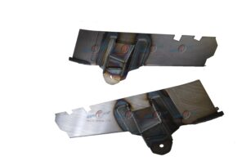Installation Instructions
IMPORTANT: Read and understand the “General Instructions for Installing SafeTCap® Frame Repair Kits” before you begin.
- Jack up the side of vehicle to be repaired and support it on properly rated jack stands. Make sure the center of vehicle is fully accessible.
- If you are repairing both sides, cut & repair one side at a time keeping one side intact and assembled as a reference/measuring point.
- Remove fuel tank and safely store at least 20ft away from the work area and any cutting, grinding or welding sparks.
- Note: You don’t need to remove cab mount or cab mount bushing from the vehicle to install the ART-242. Unless the frame behind the cab mount and bed mount is rusted.
- Take measurement of the spring mounts bolt hole center to a fixed point on the frame for later use.
- Our ART-242D have cut lines corresponding to the cab mount that can be removed if needed. Simply continue the cut lines until it’s removed.
- Slide the SafeTCap® frame repair kit over the frame from underneath
- Mark the outline of the frame repair kit on the frame with a sharpie, paint marker or soapstone. Then, remove the frame kit.
- Prep the repair area for welding by grinding the frame down to clean, bare metal along the marked outline on both the outer, and underside of the frame. Remove any rust or debris from the frame using a needle scaler. Note: For best results have your frame sand blasted prior to installation.
- Slide the frame repair kit over the frame and use large C-clamps to firmly clamp ART-242 along the top and underside of frame, and space tack welds at least every 2 to 3 inches.
- Check all measurements to make sure the vehicle has stayed straight. Check the gap between bed and cab to make sure it is parallel. Then, weld all perimeter edges 100%.
Allow the welds to cool, than rustproof the repaired area with rust inhibiting primer or undercoat. Lastly, re-attach fuel tank to the inside of the frame.

We make the Kits, that Fit!

