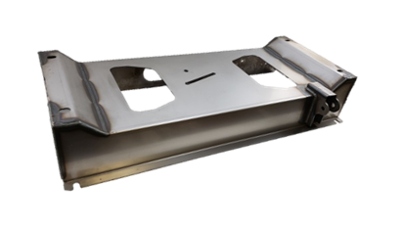
Installation Instructions
ART-211
IMPORTANT: Read and understand the “General Instructions for Installing SafeTCap® Frame Repair Kits” before you begin.
- Remove the spare tire, rear bumper, and also remove the tow hitch cross member and brackets from the frame rails.
- Disconnect the driver side shock from the shock mount on the spare tire cross member, and remove the rear 2 bed bolts that run through the spare tire cross member.
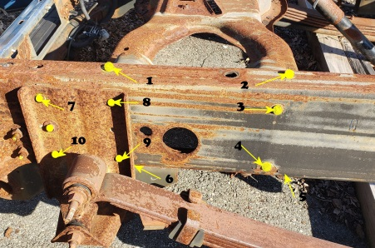
- Remove the rivets holding the rear leaf spring hangers and the spare tire cross member to the frame. They will all need to be completely removed in order to remove the cross member from the frame.
- Use jack stands to support the rear frame before completely removing the rear leaf spring hangers. Also, make sure to support the rear end from shifting.
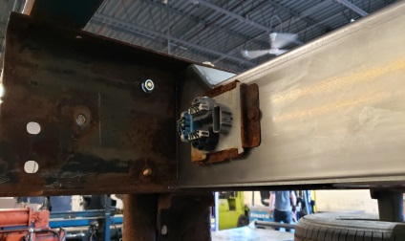
- Slide the original spare tire cross member out from between the frame rails.
- Clean any rust or debris from the inside of the frame rails.
- Remove the spare tire hoisting mechanism and the trailer lighting connector board from the original cross member and attach them to the ART-211.
- Slide the ART-211 in between the frame rails making sure that the drivers side upper shock mount in facing forward and is on the driver side.
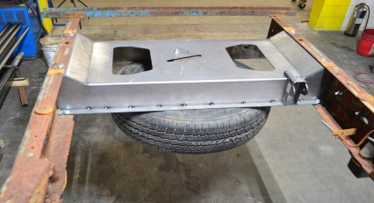
- With the hardware provided, start bolting your ART-211 to the frame.
- The hardware kit provided consists of 17ea of 7/16”x 1” gr5 Hex cap screw, and 4ea of 7/16 ” x 1 ½” hex cap screw for securing the forward 2 holes of the leaf spring hanger to the frame and cross member on both sides, and 21 flat washers and 21 serrated flanged nuts.

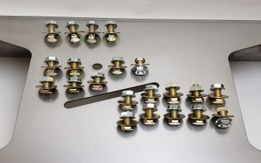
- Install all hardware to each rivet hole before tightening to make sure cross member is properly positioned. Install the leaf spring hangers using the 7” x 14 x 1½” hex cap screws for the front 2 holes on each side. Now tighten all bolts and torque the silver gr5 HCS to 50ft/lbs and the 4 gr8 HCS through the spring hanger to 70ft/lbs.
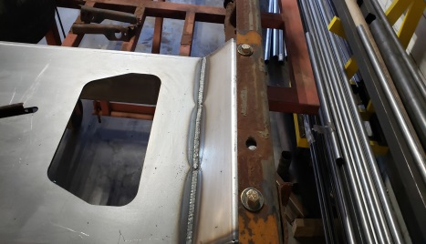
- Reinstall the 2 rear bed bolts, rear bumper and tow hitch cross member.
- Reconnect driver side shock and remove jack stands.
- Coat ART-211 cross member and all bare metal with a rust inhibiting primer.

We Make the kits that fit!

8
7

