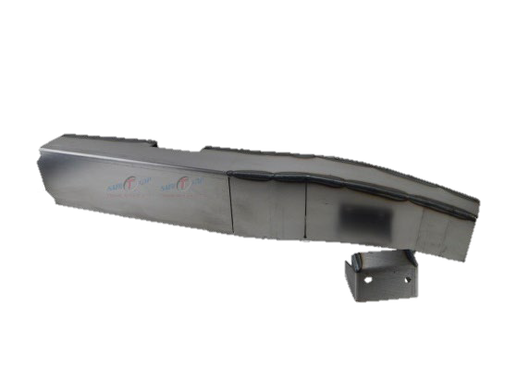
ART-240-L

Installation Instructions
IMPORTANT: Read and understand the “General Instructions for Installing SafeTCap Frame Repair Kits” before you begin.
- Jack up the front & rear of vehicle and support it on properly rated jack stands. Make sure the center of vehicle is fully accessible.
- 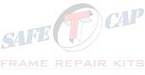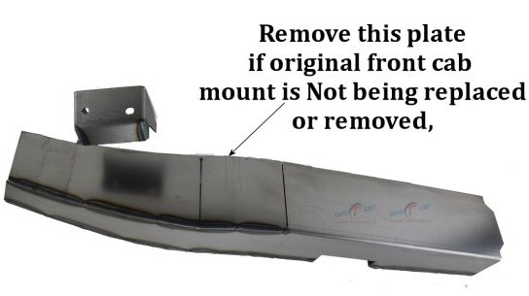Remove the front sway bar from the frame by disconnecting the sway bar links, then unbolting the sway bar mounts on both driver and passenger side. Inspect sway bar bushings, replace if necessary.
- If you are repairing both sides, cut & repair one side at a time keeping one side assembled as a reference/measuring point.
- Remove any brackets, wiring, exhaust, and fuel/brake lines from the frame and move them out of the way noting their location. You may need to drill holes in the frame kit to reattach fuel/brake line clips after installation.
- The ART-240 has 2 cut lines where the front cab mount is mounted. Determine if your original front cab mount needs to be replaced or if the metal behind the cab mount is rotted. If the cab mount is not being replaced or removed, then remove the plate by continuing the cut lines so the frame kit is notched around the cab mount.
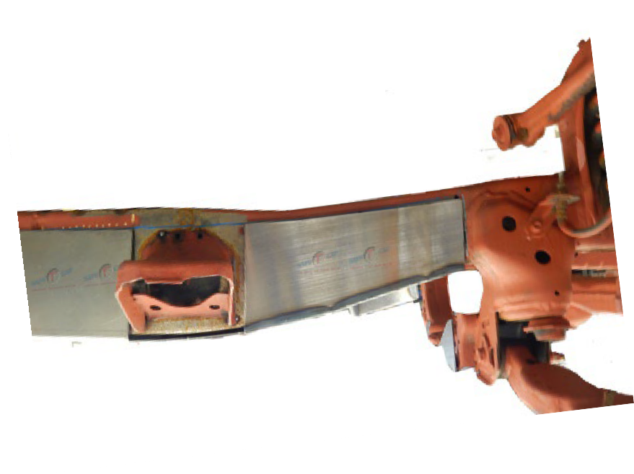
- Measure the location of the original sway bar mount, then cut the sway bar mount from the frame. Also remove any rusted and corroded sections. Note: It is best to remove the very bottom of the original frame within the covered area to allow the drain hole to drain properly.
- Slide the SafeTCap® frame repair kit over the frame from underneath and evenly space the frame kit around the cab mount and the Transmission cross member end. Mark the outline of the frame repair kit on the frame with a sharpie, paint marker or soapstone, then, remove the frame kit.

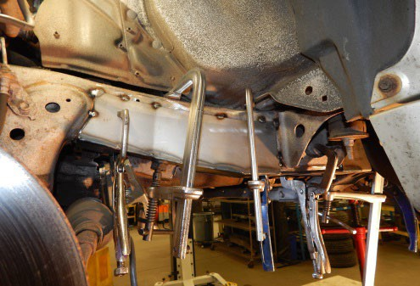
- Prep the repair area for welding by grinding the frame down to clean, bare metal along the marked outline on both the inner and outer sides of the frame. Remove any rust or debris from inside the frame using a needle scaler.
- 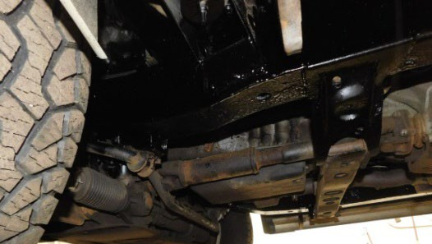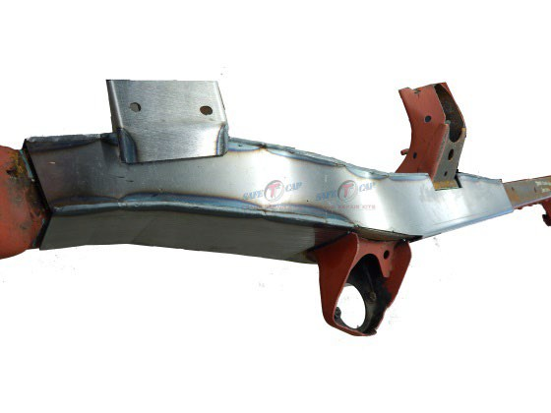Slide the frame repair kit back over the frame and use large C-clamps to firmly clamp ART-240 to the frame. Use welding clamps to tighten any gaps on the sides. Then, tack weld the frame repair kit to your frame at all corners, and space tack welds at least every 2 to 3 inches.
- The ART-240 frame kit comes with a replacement sway bar mount. Using the measurements taken earlier, tack weld the new sway bar mount to the frame. Before fully welding the new sway bar mount double check its placement on the frame. Note: Do not install sway bar bushing to the new sway bar mount until it’s been allowed ample time to cool and it’s been primed or rust proofed.
- Check measurements and door gaps to make sure the vehicle has stayed straight, then, weld all edges 100%.
- Prime or rust proof the repaired area, then re-attach
any brackets, wiring and/or brake lines back to the frame and re-install the sway bar.
We make the Kits, that Fit!

Note: Pictures in this installation instruction sheet are for demonstration purposes only and may not actually reflect the identical make, model and year of the vehicle you are working on.

