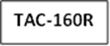
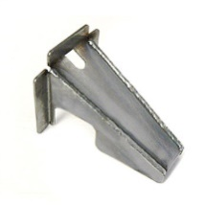
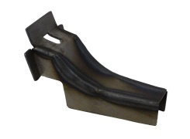
Installation Instructions
TAC-160X/D
IMPORTANT: Read and understand the “General Instructions for Installing SafeTCap® Frame Repair Kits” before you begin. Our ART-160 was designed to fit the 1996-2004 Toyota Tacoma forward fuel tank cross member ends that connect to the inner frame rails.

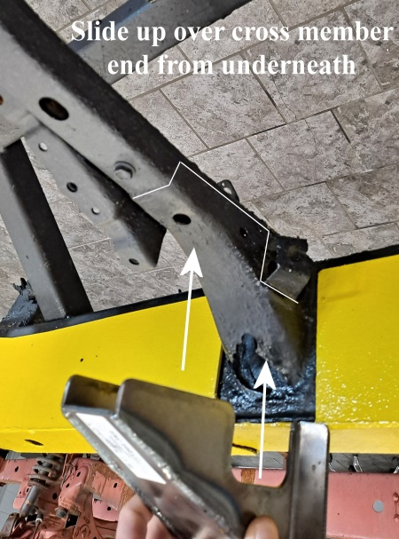
- Remove the fuel tank, Fueltank filler neck and the fuel and brake lines from the driver side inner frame.
- The TAC-160 was designed to be used with the TAC-158 and the TAC-157. If installing the TAC-160 without the 158 and 157, then the tabs for mounting against the inner frame may need to be adjusted or trimmed.
- The TAC-160R & TAC-160XD were both designed to fit over the forward fuel tank cross member ends where the cross member welds to the inner frame rails. This part is specifically made to reinforce the connection of cross member to frame. The driver side of this cross member is where the forward fuel tank strap mounts and typically rots out.
- Both TAC-160R (Reg. Cab) & TAC-160X/D(Ext/Dbl. Cab) Slide over the cross member from underneath and should be welded to the upper most edge, and also welds to the inner side of the frame rail.
- After the TAC-160 is installed and the entire perimeter edge is welded, then rust proof the repair area and reconnect all fuel and brake lines then reinstall the fuel tank and fuel tank filler neck.
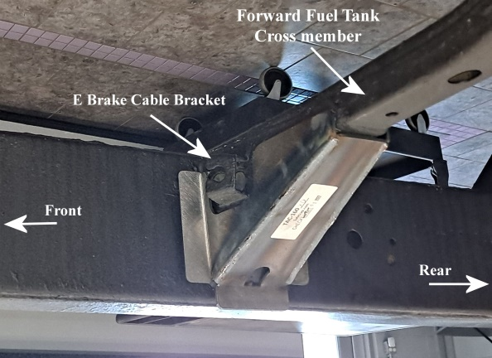
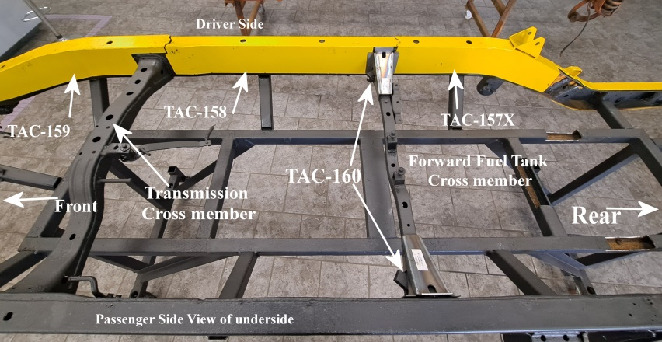

We Make the Kits, that Fit!
Pictures are for demonstration purposes only and may not exactly reflect your frame. Pictures show 1997 Toyota Tacoma Ext Cab 2wd.

