Installation Instructions .
IMPORTANT: Read and understand the “General Instructions for Installing SafeTCap® Frame Repair Kits” before you begin. Repair one side at a time for reference. Always disconnect your negative cable from battery terminal before welded to your vehicle.
- Jack up the truck, use quality jack stands with the proper weight rating and place jack stands under the frame. Make sure the entire center frame between transfer case skid plate cross member, and rear cab mount is fully accessible.
- Remove the running boards (Step Boards).
- Remove the fuel tank from the truck along with the fuel tank filler neck and store in a safe location away from any welded, sparks or open flame.
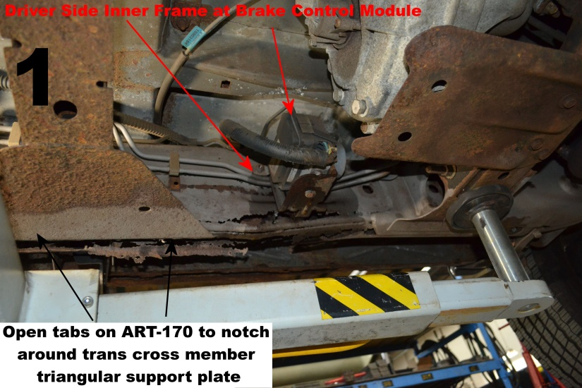
- On the inside of the driver side frame you will need to remove the brake control module from the frame along with the brake and fuel lines. Just unbolt the brake module and brake line brackets and move away from the frame. See Pic 1
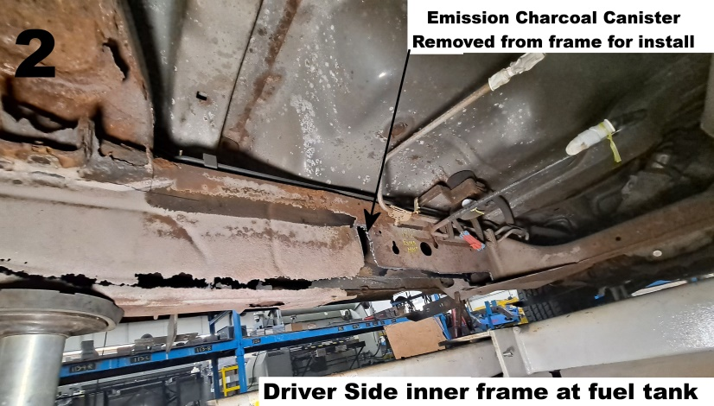
- You will also need to remove the emissions charcoal canister from the driver side inner frame and store in a safe location. Remove the charcoal canister frame mount from the frame and take measurements on its location for reinstallation later. See Pic 2
- For the passenger side frame it makes things easier if you remove the exhaust by disconnected it from the forward most exhaust flange.
- Once the frame is clear of brackets, fuel and brake lines, etc. prepare the ART-170 to slide up onto the frame by opening the inside frame tabs with a pair of vise grips to allow the frame section to fit around the triangular cross member support plates on the underside of your frame. Also if you plan to notch around the mid cab mount then remove the notch plate from the ART-170 by continuing the cut lines.
- Use a paint marker or sharpie to mark the outline of the ART-170 on the frame all along the entire perimeter then remove the ART-170 from the frame.
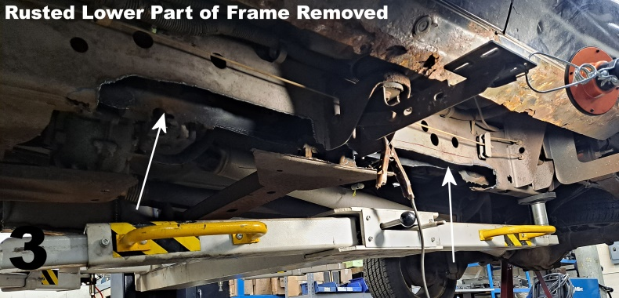
- Remove the bottom ¾” of the original frame to allow the drain holes in the ART-170 to properly work and also remove any rusted, deteriorated metal within the marked outline of the ART-170 with a plasma torch, or a cut off tool. Make sure to allow at least ¾” of the upper part of the original frame to overlap the ART-170 along the entire marked outline so the frame kit can be welded to the original frame. See Pic 3
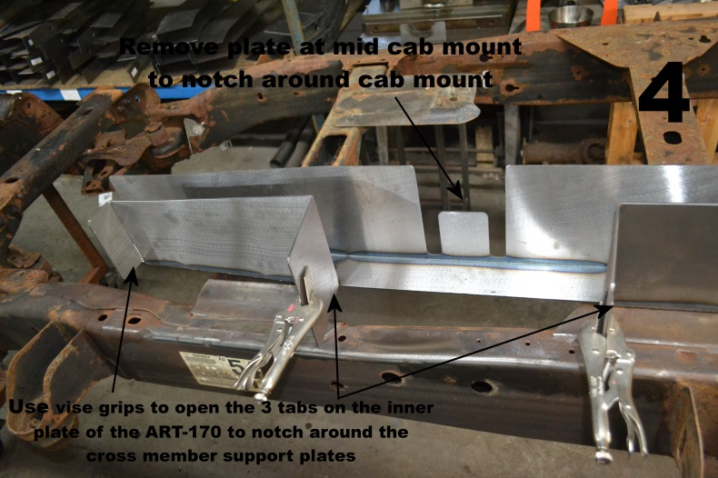
- Grind any rust and corrosion from the repair area, using the marked outline grind the frame down to bare metal all along that outline, make sure the frame is clean and oil free.
- Before fully attaching the ART-170 to the frame, drill any holes needed for reattaching the fuel and brake line brackets and also the electronic brake control module into the ART-170. Open the perforated tabs on the ART-170 inner plate to notch around the cross member support plates. 1 at the forward end and 2 in the center. See Pic 4
- Slide the ART-170 back up onto the frame and use large c-clamps to clamp the frame section firmly onto the original frame. Use welding vise grips to clamp the sides to the frame closing any gaps that might be present.
- On the inner side of frame, close the opened tabs against the inner frame above the triangular cross member support plates and clamp.
- Make sure the ART-170 is properly seated against the original frame and there are no gaps, also make sure that the frame section isn’t over clamped, which could cause issues while welding and after. Tack weld the entire ART-170 at all corners then every 4” to 6” in between.
- Weld the entire perimeter of the ART-170, don’t focus too much heat in any one area at a time, weld with 4” to 6” beads, move from front to back and inside to outside, and take a few minutes break in between welds to allow cooling. Make sure to weld the 3 relief cuts on the inside of the ART-170 for the cross member support tabs.
- If installing both sides, begin installing opposite side now.
- Reattach and weld the Charcoal canister mounting plate onto the frame using the measurements taken earlier, and allow welds to cool.
- Rustproof the entire repaired area with a rust inhibiting primer or undercoating.
- Also reattach the brake and fuel lines to the frame as well as the electronic brake module to the inside of the frame, do not weld the brake control module back onto the frame, use the original hardware if possible, or use new hardware.
- Reinstall fuel tank and fuel tank filler neck back to the vehicle, don’t forget to plug the fuel pump wire harness in and connect the grounding wires to the frame.
- Re-connect the exhaust if you removed it, make sure to use new donut gaskets when reconnecting exhaust flanges.
- Reconnect battery negative terminal and fill fuel tank with gas. Re install the running boards and make sure all bolts are torqued properly.

We make the Kits, that Fit!
Note: Pictures in this installation instruction sheet are for demonstration purposes only and may not actually reflect the identical make, model and year of the vehicle you are working on.

