Installation Instructions
IMPORTANT: Read and understand the “General Instructions for Installing SafeTCap® Frame Repair Kits” before you begin. Repair one side at a time for reference.
- Jack up the rear of the truck, use quality jack stands with the proper weight rating and place jack stands under the frame, 1 before the rear axle and 1 after, allowing the rear end to hang free. Use the hyd. Jack under the differential to take the weight off the rear end.
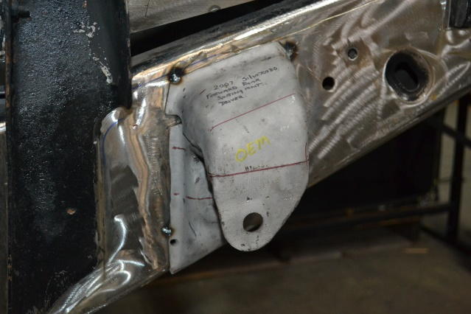
- Disconnect the leaf spring from the leaf spring mount and lower the axle with a hydraulic jack to move the spring away from the repair area.
- Measure the original mounts bolt hole center from a fixed point nearby on the frame. Horizontal and lateral measurement.
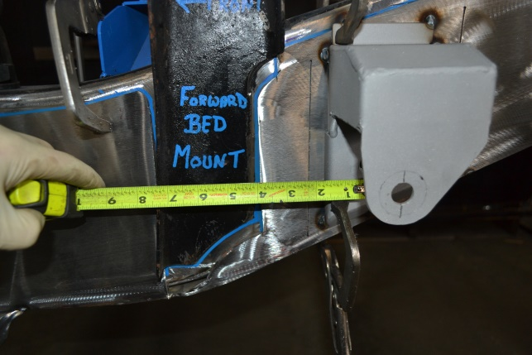
- Cut the welds holding the original spring mount to the frame, be careful not to cut too much into the frame, then remove the original mount.
- Inspect the frame at and around the original mount location to make sure it can withstand being welded to and is thick enough to allow for proper weld penetration.
- Grind any rust and corrosion from the repair area, make sure the frame is clean and oil free.
- Place the ART-171 onto the frame and using the measurements taken earlier set the new spring mount into position and tack weld the corners.
- Double check its placement, you can even dry fit the leaf spring mount. Placement must be exact to original.
- Weld the entire perimeter of the ART-171, allow time between welds for cooling, so you don’t focus too much heat in any one area at a time.
- Allow the repair area to cool, then rust proof the repair area.
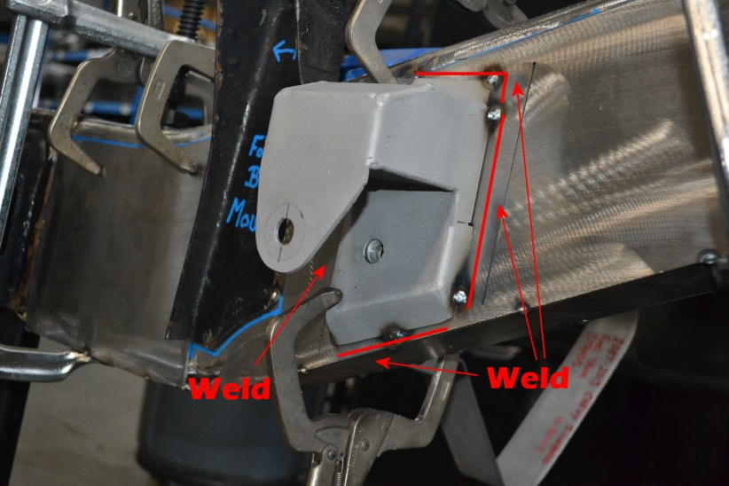
- Reinstall the leaf spring to the ART-171 with the new hardware provided and torque bolt to vehicle spec. 148lbs ft .
- Reinstall rear wheel and lower vehicle to the ground, unless installing the other side.
- Test Drive vehicle, then double check suspension.

We make the Kits, that Fit!

Note: Pictures in this installation instruction sheet are for demonstration purposes only and may not actually reflect the identical make, model and year of the vehicle you are working on.

