Installation Instructions
IMPORTANT: Read and understand the “General Instructions for Installing SafeTCap Frame Repair Kits” before you begin. Hardware to replace rivets included.
- Jack up the rear of the truck and support the frame with properly rated jack stands. Place the jack stands under the frame just after the rear axle.
- Remove the rear tires, the spare tire, rear bumper, and trailer hitch cross member (if truck is equipped). Unscrew the rear 2 bed bolts, they’re located inside the bed of the truck, if there is a bed liner, you will need to lift the bed liner to access bolts.
(NOTE: The truck bed does not need to be fully removed to install the ART-167.)
- Measure the distance from the leaf spring hangers to the end of the frame and take note, this measurement will be needed.
- You should support your rear axle with a hydraulic jack under the differential before disconnecting the rear leaf springs, use the jack to hold the weight of the differential so the rear suspension is not hanging.
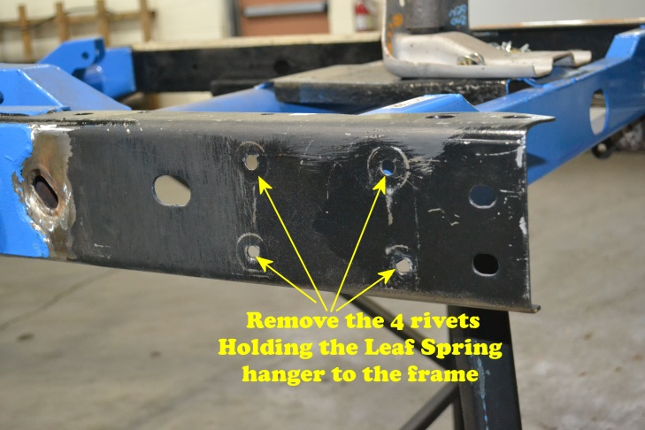
- Then, carefully cut the heads off the 4 rivets holding the leaf spring hangers to the frame. You don’t need to remove the leaf spring from the hanger, it is easier to leave it mounted to the hanger.
- Slide the ART-167 SafeTCap® Rear Frame kit over the frame, line up the holes for the leaf spring hanger, and line up to the end of the frame. Make a mark with a sharpie or paint marker on the original frame where the ART-167 overlaps, then remove the frame kit.
- Grind the frame to clean, bare metal an inch before and after the marked line where the ART-167 overlaps and remove any rust or debris from the remaining frame using a grinder or a needle scaler.
- Slide the ART-167 back over the frame and line up the leaf spring hangar holes and the end of the frame. Clamp the frame kit tightly to the frame.
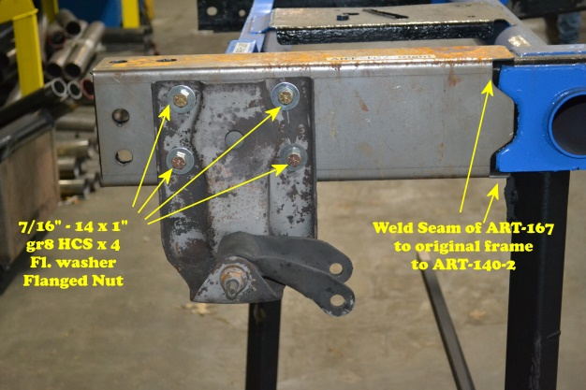
- Tack weld the ART-167’s forward inside and outside edge to the original frame. Check the ART-167’s position using measurements taken earlier.
- After ensuring the ART-167 is in proper position, weld the entire inner and outer edge of the ART-167 to the frame.
- Allow the welds to cool, then, re-attach the leaf spring hanger to the frame by lining up the holes in the frame and the ART-167, using measurements taken earlier check that the spring hangar is aligned correct. Leaf spring hangar position should be identical on both driver and passenger sides.
- You can tack weld the spring hangars to the frame in addition to the hardware provided. Install the 7/16” – 14 x 1” gr.8 HCS with washer and flanged nut to secure the hangar to the frame. Torque each bolt to approximately 63ft/lbs.
- Once completed, coat the repair areas with a rust preventative primer or an undercoat.
- Reinstall the rear 2 bed bolts, the rear bumper, and reconnect the trailer hitch cross member (If equipped). Remount the rear tires and re-attach the spare tire.
- Lower vehicle to the ground, and test drive.
- Inspect your repair after test drive, then after a month.

We make the Kits, that Fit!

Note: Pictures in this installation instruction sheet are for demonstration purposes only and may not actually reflect the identical make, model and year of the vehicle you are working on.

