Installation Instructions
IMPORTANT: Read and understand the “General Instructions for Installing SafeTCap® Frame Repair Kits” before you begin. Our ART-169 was designed to fit the Reg Cab 2nd gen Silverado/Sierra 1500.
- Jack up the rear of the vehicle with a hyd. jack and use properly rated jack stands to support the frame and the rear axle.
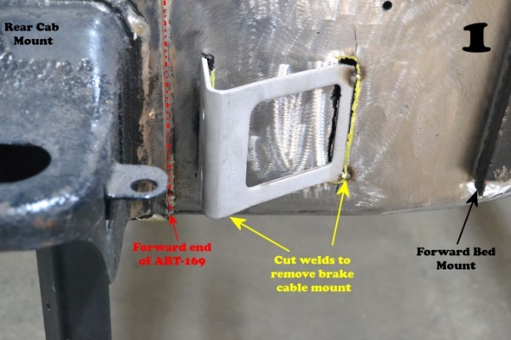
- Remove the fuel tank and the fuel tank filler neck from the vehicle and store the fuel tank a safe distance from the work area. Tie off and seal the open fuel lines using the “Fuel Line Safety Kit” provided.
- Unclip the fuel and brake lines from the frame rails, also any wiring and brake cables must be carefully moved away from the frame rails where the fuel tank cross member connects.
- The e-brake cable mount on the driver side, right after the rear cab mount, will need to be removed from the frame. Measure its location from the rear cab mount. Carefully cut the welds that hold the cable mount to the frame, this mount will need to be re-welded onto the frame after installing the frame kit. See pic 1
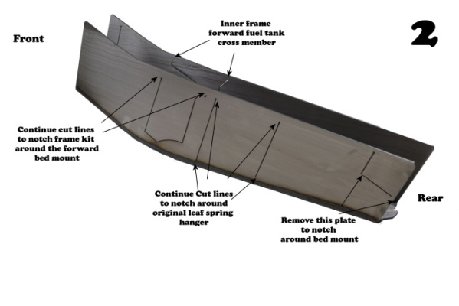
- If you’re installing the passenger side, the exhaust hanger on the inside of the frame will need to be removed and re-welded after installing the frame kit. Or the ART-169 can be notched to go around.
- The ART-169 can be installed a few different ways depending on the severity of rust, or damage to this particular part of your vehicles frame. The outer side of the frame kit will have multiple cut lines, that if you continue the cut lines your able to remove areas of the frame kit to replace metal behind the rear spring mount, or notch around the bed mount. See Pic 2.
- If installing our ART-170, do not remove the corresponding plate on the ART-169. See Pic 2. Our ART-170 should be installed and welded onto the new metal of the ART-169 after it’s installed.
- Grind the area of the frame you are repairing, removing all rusted debris, oils, dirt, undercoating and paint. For least 1 inch up and within the covered area the ART-169 provides, you may need to mark the frame using the frame kit as a guide. See Pic 3.
- Prepare the ART-169 for installation onto the frame, configure the frame for your trucks specific rust or damage by removing plates between the cut lines, Ref step 6.
Optional: You can coat the inside of the ART-169 with a weld through primer, or a weld safe primer to prolong the life of the repair.
- Slide the frame kit up over the frame from underneath, you may need to use a dead blow hammer, or very large C-clamps to firmly clamp the frame kit to the original frame. Ensure the entire perimeter where the ART-169 meets the original frame is ground down to bare metal. If not, then mark that area with a marker and remove frame kit to finish grinding. See Pic 3.
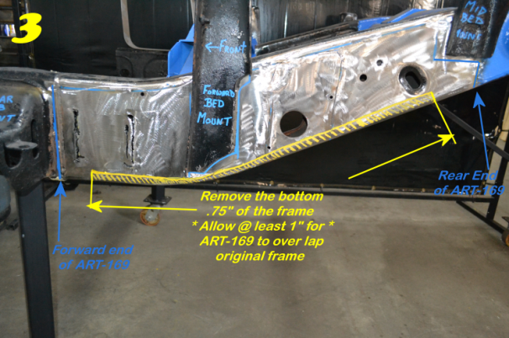
- Once the ART-169 is firmly capped over the original frame, make sure the frame kit is aligned and positioned properly. This frame kit should start right after the rear cab mounts rear flange. See Pic 4.
- If you removed the plate to notch around the bed mount and the original leaf spring hanger then also make sure that the gap around each notched component is evenly spaced. Once the frame kit is properly seated on the original frame, close any gaps between the ART-169 and the original frame using large C-clamps and/or welding clamps. See Pic 4.
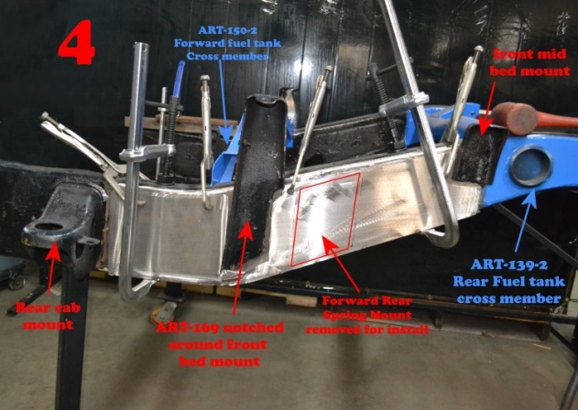
- Tack weld the ART-169 to the original frame starting at the upper corners and wherever there is a welding clamp. Space tack welds out every 4” to 6” inches at least.
- Remove all clamps and check the entire perimeter of the frame kit. Make sure to leave no gaps between the frame kit and original frame.
- Weld the entire perimeter of the ART-169. Use 4 to 6 inch welds and space welds out. Switch between inner frame and outer frame so you are not overheating any one part of the frame too much. Overheating can cause you to burn through the original frames metal, and also cause the metal to warp. When welding make sure to follow safe welding procedures and always have a second person nearby on fire watch, keep a fire extinguisher close and do not have any flammable items closer than 2 feet from the welding area.
- Allow at least 15 mins from final weld for the welds to cool off. If installing other frame sections, begin them before rustproofing and/or coating the repaired area.
- Rustproof the repaired area to prolong the life of your frame. There is many good rustproofing products out there, but we prefer to use “Kirker Super Rust Stop” for small repairs and a petroleum based undercoat for larger repairs and entire frames.
- After rustproofing, reinstall each part removed for this repair. Using the measurements taken, re-weld the e-brake cable mount to the driver side and connect the brake cables exactly as they were before. Re-connect the fuel and brake lines to the inside of the frame and also re-install the fuel tank and fuel tank filler neck, do not forget the grounding cables.
- Remove jack stands and lower vehicle to the ground and fill fuel tank, start the engine and check for leaks.
- Test drive vehicle then double check repaired area, fuel tank for leaks, and suspension to make sure everything is normal and safe.
We Make the Kits, that Fit!
8

