Installation Instructions
IMPORTANT: Read and understand the “General Instructions for Installing SafeTCap® Frame Repair Kits” before you begin. Our ART-168 was designed to fit the 2nd gen Silverado/3rd gen Sierra 1500.
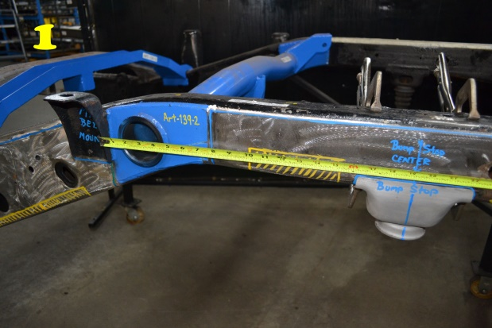
This part does not come with a new Urethane Bump Stop.
*Installations steps in highlight are broken down to the main installation points for the more experienced installer.*
- Jack up the rear of the vehicle with a hyd. jack and use properly rated jack stands to support the frame.
- Remove the Rear tire on the side you are repairing.
- Unbolt the Bump stop from the frame mount and set aside if you’re re-using it. Use a 10mm socket with long extension.
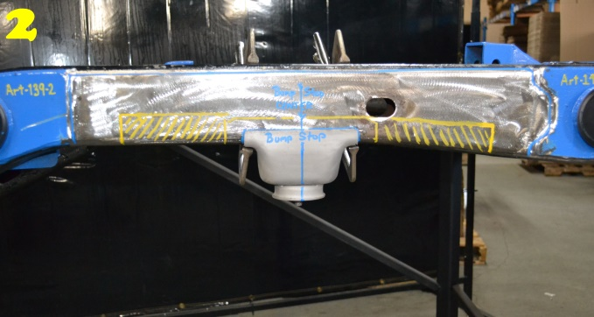
- Measure the bump stop bolt hole center to a fixed point on your frame, take note of that measurement. Also mark the center of the bump stop bolt hole and run the line up the outside of the frame to the top. See Pic 1
- Cut off the original bump stop mount from your frame, you will need to remove the entire bump stop, welds included. Cut ½ ” above welds into frame all the way around the bump stop mount till it’s completely removed from your frame.
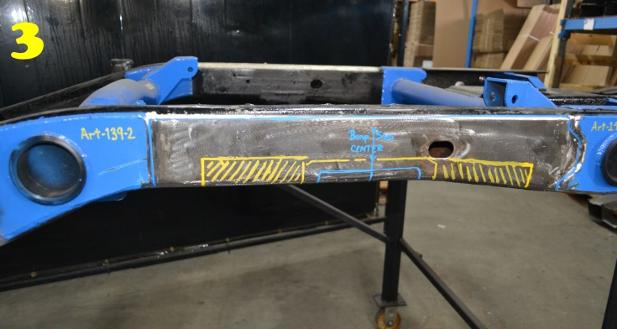
- Depending on the condition of your frame you may need to remove more of the bottom part of your frame, test fit the ART-168 over the frame till the bottom of your frame meets the bottom of the frame kit and clamp both ends of the frame kit to the original frame. See pic 2 & 3
- Mark the entire outline of the ART-168 with a marker, paint pen, or soapstone, then remove the frame kit.
- For best results, we suggest removing at least the bottom 1” of the original frame to allow the ¾ ” drain hole to function properly.
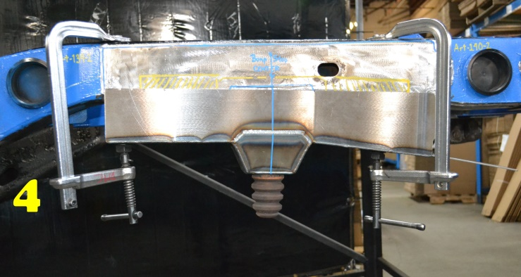
See pic 3. The yellow hatched areas in pic 3 are usually the most of the lower original frame we’d suggest to remove, allow 2” inches of the original frame at the front and rear for the ART-168 to overlap.
- Grind the frame down to bare metal to remove all paint, undercoating, and oils all the way around the blue outline in pic 3, marked during test fit of frame kit.
- Slide the ART-168 up over the frame and use the measurement taken earlier to line up the bump stop bolt hole center, Use large C-clamps the close any gaps between the frame kit and original bottom of your frame. See Pic 4. Use welders clamp to close any gaps in the sides of the ART-168.
- Tack weld the ART-168 to the original frame starting at the upper corners and wherever there is a welding clamp. Space tack welds out every 4” to 6” inches at least.
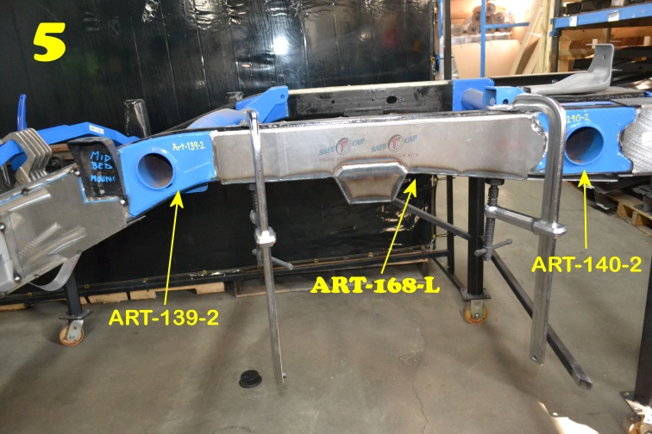
- Remove all clamps and check the entire perimeter of the frame kit. Make sure to leave no gaps between the frame kit and original frame.
- If installing subsequent frame repair kits, ART-167, ART-169, we suggest installing these parts before fully welding ends of the ART-168 that meet.
- Weld the entire perimeter of the ART-168. Use 4” to 6” inch welds and space welds out. Switch between inner frame and outer frame so you are not overheating any one part of the frame too much. Overheating can cause you to burn through the original frames metal, and also cause the metal to warp. When welding make sure to follow safe welding procedures and always have a second person nearby on fire watch, keep a fire extinguisher close and do not have any flammable items closer than 2 feet from the welding area.
- Allow welds to cool, then rustproof the repaired area to prolong the life of your frame. There are many good rustproofing products out there, but we prefer to use “Kirker” brand, “Super Rust Stop” for small repairs and a petroleum based undercoat for larger repairs and entire frames.
- After rustproofing, bolt on the bump stop to the ART-168. The ART-168 has an m10-1.5 weld nut and m10-1.5 x 100 Tap bolt.
- Re-attach the wheels and ensure the lugs are properly torqued, then remove the jack stands and lower the vehicle to the ground..
- Test drive vehicle then double check repaired area, and suspension to make sure everything is normal and safe.
8

We Make the Kits, that Fit!

