Installation Instructions
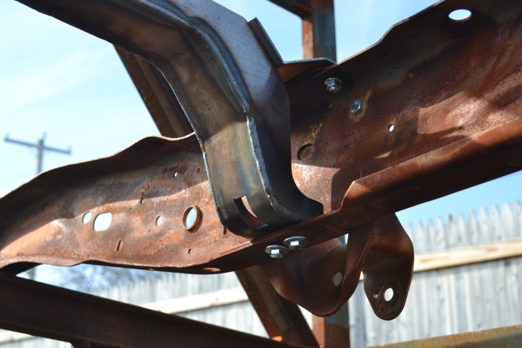
IMPORTANT: Read and understand the “General Instructions for Installing SafeTCap® Frame Repair Kits” before you begin.
- Jack up the rear of the vehicle with a hyd. jack and use properly rated jack stands to support the frame and the rear axle.
- Remove the fuel tank and the fuel tank filler neck from the vehicle and store the fuel tank a safe distance from the work area. Tie off and seal the open fuel lines using the “Fuel Line Safety Kit” provided.
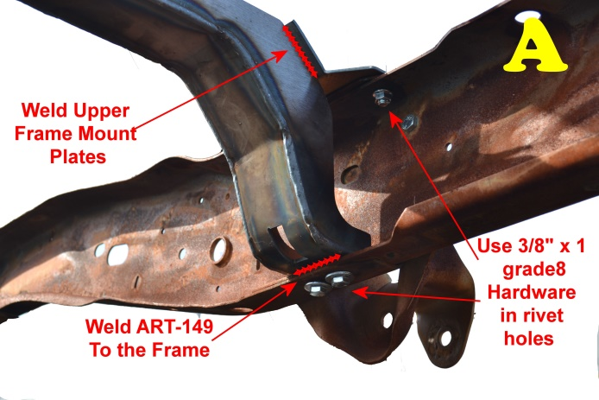
- Unclip the fuel and brake lines from the frame rails, also any wiring and brake cables must be carefully moved away from the frame rails where the fuel tank cross member connects.
- To remove the original cross member, the rivets on the top and bottom of both driver and passenger side frame rails will need to be removed completely. They must be either drilled out, plasma cut or torched, or grind the rivets head down flush with the frame, then air hammer the remaining rivet out from frame.
- Once all 8 rivets securing the original fuel tank cross member to the frame are removed, clean the frame rails around the repair area of any rust, dirt, oils, and debris.
- Insert the ART-149 in between the frame rails so the ends of the ART-149 rest on the lower inner edges of the frame rail. Line up the original rivet holes with the slots on the ART-149.
- Make sure the fuel tank strap slot and mounting bolt are positioned on the driver side, and the ART-149 is horizontally perpendicular to the frame rails on both driver and passenger sides.
- To permanently mount the ART-149 to the frame, you can use 3/8”–16 x 1” gr8 HCS, serrated flanged nut, and washer in each rivet hole, 4 on the driver and 4 on the passenger side. We highly recommend welding the ART-149 to the frame in addition to using hardware.
- The 2 upper frame support plates are shipped loose with the ART-149. Once the cross member is mounted to the frame and bolted and/or tack welded, ensure the cross member is vertically perpendicular to the frame rails, then loosely bolt in the upper frame support plates to the top of the frame using the upper rivet holes. Then tack weld the upper frame mount plates to the top outer ends of the ART-149. See diagram A. →
- Double check alignment and position of the ART-149, make sure the fuel tank strap mount slot and mounting bolt are on the driver side, and cross member is both horizontally and vertically perpendicular to the frame rails. Make adjustments if necessary.
- Important: Make sure the fuel lines, brake lines and cables are properly oriented around the ART-149 in their OEM position before moving on to the next step. Failure to follow this step may result in a catastrophic failure in brake system or fuel system.
- Tighten the hardware used in the rivet holes. 8ea of 3/8” - 16 x 1” gr8 HCS, torque to 40lb ft.
- Optional, but Recommended: Weld the upper and lower ends of the ART-149 both driver and passenger sides where they contact the original frame. See diagram A.
- Allow welds to cool, then rust proof the ART-149 inside and out, as well as both sides of the frame, in and out, to prolong the life of the repair. There are many options for rust prevention on the market today, at Auto Rust Technicians, we use Kirker brand, Super Rust Stop, as a base coat. And for best results we use a petroleum based undercoating.
- Once all paint or undercoating is dry, re-install the fuel tank and make all necessary electrical and fuel line connections. Inspect the fuel tank straps for rust, cracks and splits, or damage, and replace if necessary.
- Reinstall the fuel tank filler neck and ensure it’s clamped firmly to the fuel tank. Do not overtighten the clamp at the fuel tank. Also make sure any grounding wires are also re-connected to the frame.
- Remove all jack stands and lower vehicle to the ground, fill fuel tank with fuel and start the vehicle. Check for any leaks.
- Test drive vehicle then double check repaired area and fuel tank.

We Make the Kits, that Fit!
8

