Installation Instructions
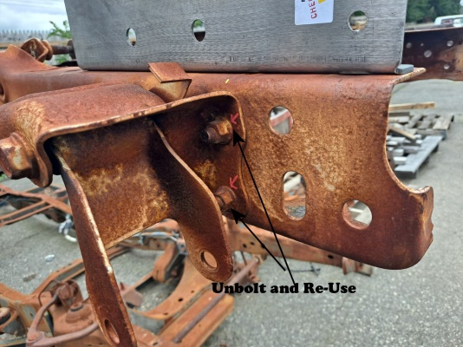
IMPORTANT: Read and understand the “General Instructions for Installing SafeTCap Frame Repair Kits” before you begin. Hardware not included.
- Jack up the rear of the truck and support the frame with properly rated jack stands. Place the jack stands under the frame just after the rear axle.
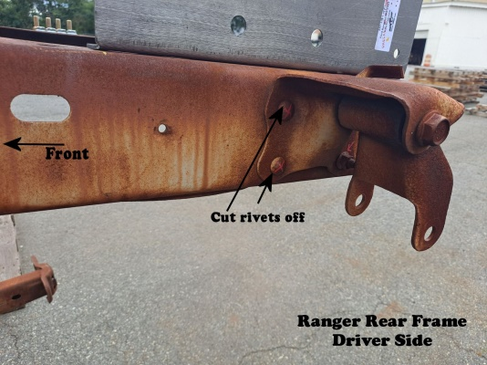
- Remove the rear tires, the spare tire, rear bumper, and trailer hitch cross member (if truck is equipped). Unscrew the rear 2 bed bolts, they’re located inside the bed of the truck, if there is a bed liner, you will need to lift the bed liner to access bolts.
(NOTE: The truck bed does not need to be fully removed to install the ART-120.)
- Measure the distance from the leaf spring hangers to the end of the frame and take note, this measurement will be needed.
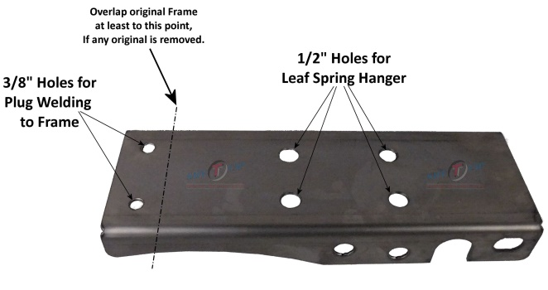
- You must support your rear axle with a hydraulic jack under the differential before disconnecting the rear leaf springs, Do not jack up the rear axle, just use the jack to hold the weight of the differential so the rear suspension is not hanging.
- Then, carefully cut the heads off the 4 rivets holding the leaf spring hangers to the frame. You do not need to remove the leaf spring from the hangar, it is easier to leave it mounted to the hanger.
Pic of ART-120-L Driver side
- Slide the ART-120 SafeTCap® Rear Frame kit over the frame, line up the holes for the leaf spring hanger, and line up to the end of the frame. Make a mark with a sharpie or paint marker on the original frame where the ART-120 overlaps, then remove the frame kit.
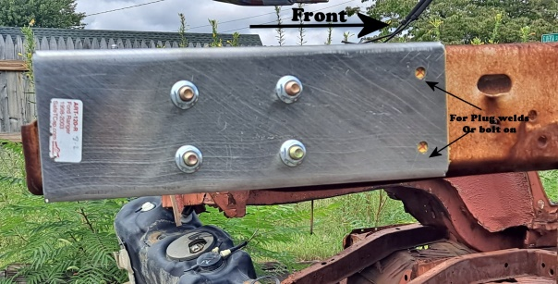
- Grind the frame to clean, bare metal an inch before and after the marked line where the ART-120 overlaps, both inside and outside of the frame, and remove any rust or debris from the remaining frame using a grinder or a needle scaler.
- Slide the ART-120 back over the frame and line up the leaf spring hangar holes and the end of the frame. Clamp the frame kit tightly to the frame.
- Tack weld the ART-120’s forward inside and outside edge to the original frame. Check the ART-120’s position using measurements taken earlier.
- After ensuring the ART-120 is in proper position, weld the entire inner and outer edge of the ART-120 to the frame.
- Allow the welds to cool, then, re-attach the leaf spring hangar to the frame by lining up the holes in the frame and the ART-120, using measurements taken earlier check that the spring hangar is aligned correct. Leaf spring hangar position must be identical on both driver and passenger sides.
- You can either weld the spring hangars to the frame or use hex cap screws with flange nuts to secure the hangar to the frame or both welds and hardware.
- If installing both sides, begin installing the opposite side ART-120. Once completed, coat the repair areas with a rust preventative primer or an undercoat.
- Reinstall the rear 2 bed bolts, the rear bumper, and reconnect the trailer hitch cross member (If equipped). Remount the rear tires and re-attach the spare tire.
- Lower vehicle to the ground, and test drive.
- Inspect your repair after test drive, then after a month.

We make the Kits, that Fit!
Note: Pictures in this installation instruction sheet are for demonstration purposes only and may not actually reflect the identical make, model and year of the vehicle you are working on.

