Installation Instructions
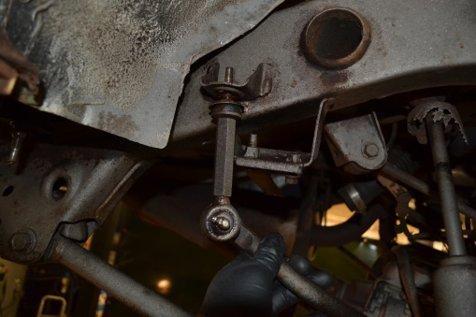
IMPORTANT: Read and understand the “General Instructions for Installing SafeTCap® Frame Repair Kits” before you begin installation. Make sure to disconnect battery before any welding or plasma cutting is performed on the vehicle.
- Jack up the rear of the vehicle and support the frame on properly rated jack stands. Allow the rear axle to hang free so the suspension is unloaded. Remove the rear tires.
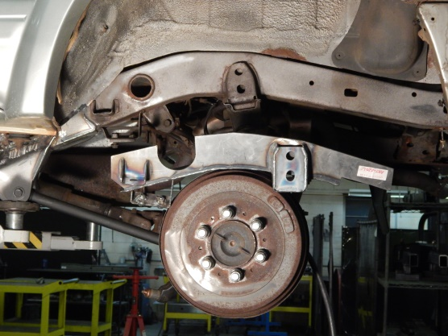
- Remove the fuel tank from the vehicle and store it at least 20 feet from the repair area, cover the fuel tank with a fire proof blanket to protect it from sparks. Cover the exposed fuel lines with a ziplock bag or vinyl gloves and tie them off so the fuel vapor doesn’t ignite.
- Disconnect the rear sway bar links from the frame on both driver and passenger sides, replace if necessary. Swing the sway bar down or remove it from the rear axle completely so it’s not in your way. Check all the sway bar bushings for cracking, replace is necessary.
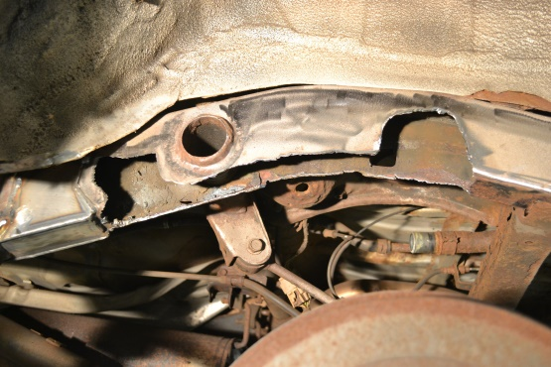
- If your repairing both driver and passenger side frames, make sure to only cut and repair one side at a time, keeping one side intact as a reference.
- Put a Hydraulic jack under the rear axle to support it, then disconnect the shock. Remove the coil spring, it helps to have a spring compressor tool.
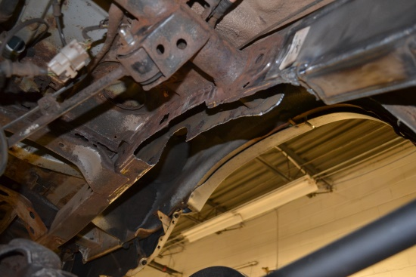
- Unbolt the bump stop from the bump stop mount and put side for later use.
- Take measurements of the sway bar link bracket, the fuel tank strap bracket and the bump stop to ensure placement of the ART-220 is correct when aligning.
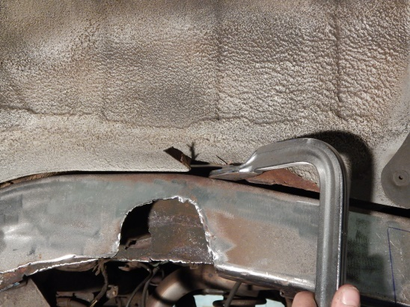
- Remove the fuel tank strap bracket, the sway bar link bracket and the bump stop from the frame with a plasma torch, or cut-off tool and grind flat to the frame. Or you can cut the entire lower section of the frame within the perimeter of the ART-220, by carefully cutting around those mounts. Do not cut too high on the frame, make sure all cut areas are covered by the ART-220 with at least a half inch overlap.
- Grind all edges down to clean bare metal and also grind the upper edge of the frame where the ART-220 will be welded.
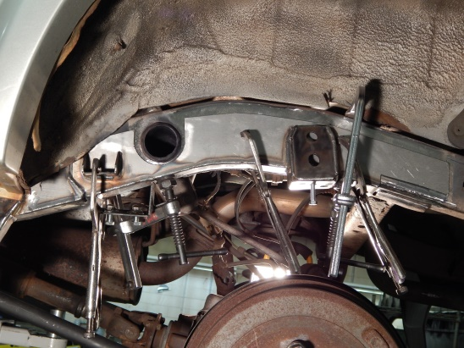
- Slide the ART-220 onto the frame from underneath and clamp the frame kit to the frame ensuring the gaps are all closed firmly.
- With the measurements taken earlier make sure that the ART-220 is aligned and properly placed on the frame. Tackweld the ART-220 to the frame at all corners and at least every 3” to 4” inches.
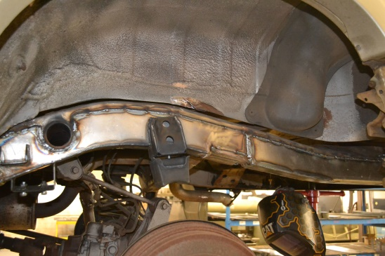
- Double check measurements, then weld the entire perimeter of the Art-220 both inside the frame and outside. It helps to weld in 3” inch stitch welds and move around the frame kit between welds so you don’t overheat any one part of the frame.
- If installing more SafeTCap® frame kits on this side, do not weld the forward or rear end where that other frame kit will meet yet.
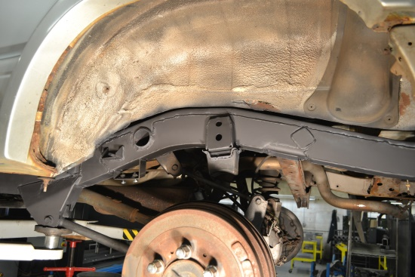
- If your planning to install the opposite side frame kit then do so now before coating the frame and reinstalling suspension parts.
- Allow welds to cool, then rustproof the repaired area with a rust inhibiting primer, Rustoleum, or undercoating.
- Reinstall the fuel tank and all fuel lines, and filler neck.
- Re-install the coil springs, shocks and sway bar links and the tires.
- Lower vehicle to the ground and double check all components for proper fit.
We Make the Kits, that Fit!

