Installation Instructions
IMPORTANT: Read and understand the “General Instructions for Installing SafeTCap® Frame Repair Kits” before you begin. Disconnect the negative battery terminal or remove the battery from vehicle before welding or plasma cutting the frame of the vehicle.
- Jack up the rear of the vehicle and support the frame on properly rated jack stands. Make sure the rear of vehicle is fully accessible. Place jack stands 1 set before the rear axle and another set on the frame at the bump stop or just behind.
- The TAC-234X/D is 24.5” inches long so you must make sure you don’t place jack stands on your frame within 26” inches from the rear end of the frame.
- If both sides (Driver and Passenger) of the frame need to be repaired, cut & repair one side at a time keeping one side assembled as a reference/measuring point.
- Remove the spare tire, and the rear bumper from the frame. If your vehicle has a tow hitch cross member, it will also need to be removed from the frame.
- We design our SafeTCap® Frame repair kits to be installed without having to remove the bed of the truck. With the bed of the truck left bolted to the frame, it provides needed stability and ensures the frame doesn’t twist or become unable to re-mount the bed after repairing the rusted frame sections.
- Remove the rear 2 bed bolts. Do not unbolt the remaining bed bolts.
- Measure the location of the rear leaf spring hanger on the frame and take note for later use.
- Place a Hyd. Jack under the rear axle to support it during the removal of the rear spring hangers.
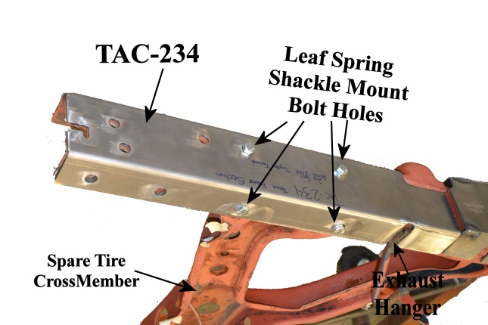
- Then, remove the rear leaf spring hanger from the frame by grinding the heads of the rivets down, then drilling the remaining rivets from the frame.
- Slide the TAC-234X/D over the frame from the outside, make sure the rear end of the frame kit lines up with the original frame end. Then, mark the forward end of the TAC-234 on the original frame with a paint pen, Sharpie or soapstone.
- Remove the TAC-234 from the frame and grind the frame down to clean, bare metal at least 2” inches before and after the marked line on the frame as well as the upper and lower edge of the original frame.
- Prep the repair area for welding by grinding the frame down to clean, bare metal along the marked outline on both the outer, and underside of the frame. Remove any rust or debris from the frame using a needle scaler. Note: For best results have your frame sand blasted prior to installation.
- Once frame is prepped, Slide the TAC-234 back over the frame and clamp to the original frame with welding clamps.
- Weld the upper and lower inner edges of the TAC-234 to the frame, then weld the forward edge of the 234 to the frame.
- Using the measurements in step # 7, reattach the rear spring hanger to the frame by either bolting it to the frame or welding the spring hanger to the TAC-234 Frame Kit. If you have disconnected the rear leaf spring from the Spring hanger, re-connect the leaf spring to the spring hanger and torque to specification.(89ft-lbs)
- If any of the weld nuts in the original frame for mounting the rear bumper, spare tire cross member and the tow hitch cross member were rotted, damaged and/or needed to be removed from the original frame, then new weld nuts will need to be added to the TAC-234 in the proper holes before rustproofing the repaired area.
- Allow at least an hour for the welds to cool, then rustproof the repaired area with a rust inhibiting primer or undercoating
- Once rustproofing is dry, Reinstall the 2 rear bed bolts, any wiring and clips to the frame, the rear bumper, the tow hitch cross member and spare tire.
- Remove jack stands, lower vehicle to the ground and test drive. Double check suspension after test drive to make sure nothing is loose.
We make the Kits, that Fit!

