Installation Instructions
IMPORTANT: Read and understand the “General Instructions for Installing SafeTCap® Frame Repair Kits” before you begin. Disconnect the negative battery terminal or remove the battery from vehicle before welding to the frame of the vehicle.
- Jack up the rear of vehicle and support the frame on properly rated jack stands so the rear axle hangs free and suspension is unloaded. Make sure the area above the rear axle is fully accessible.
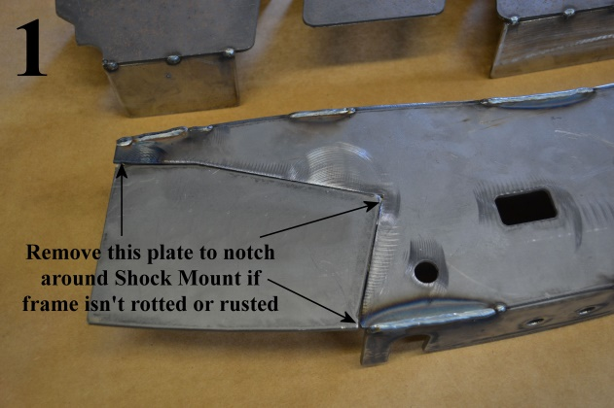
- If you are repairing both sides, cut & repair one side at a time keeping one side assembled as a reference/measuring point.
- Remove fuel tank and safely store at least 20ft away from the work area and protect it from any cutting, grinding, or welding sparks by wrapping it in a fire proof blanket.
- Support the rear axle with a Hyd. Jack and disconnect both Driver and Passenger side shocks from the frame. Inspect each shock and the rubber boots, replace if necessary.
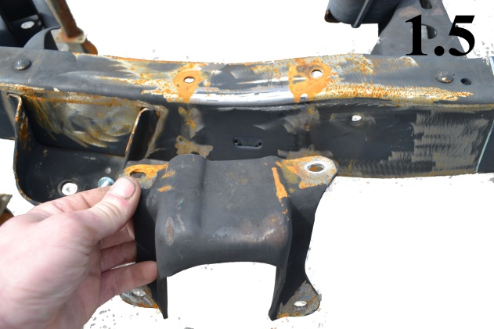
- To install the TAC-233, you don’t need to remove the bed from the vehicle, it helps to leave the bed bolted onto the frame as it will ensure the frame doesn’t twist or bend during the repair.
- Measure the bump stop and note its location. Carefully remove the rivets holding it to the frame, try not to destroy the bump stop during removal, you will need to reinstall it after the TAC-233 is welded on.
- For the Passenger Side: If the frame behind the shock mount is rusted out, measure its placement and remove it from the frame carefully so it can be welded back onto the frame after the TAC-233 is welded.
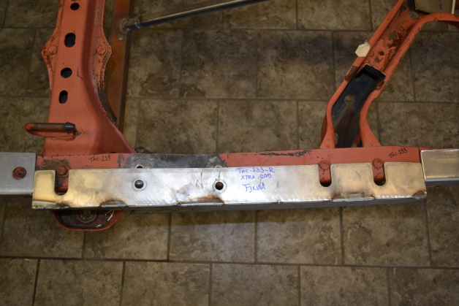
- Prep the repair area for welding by grinding the frame down to clean, bare metal on the outer side, under side, and upper side of the frame. Remove all rust and/or debris from the frame using a needle scaler. Note: For best results have your frame sand blasted prior to installation.
- Slide the TAC-233 SafeTCap® frame repair kit over the frame from the outside and line up the slots around the rivets on the top and bottom, tap the TAC-233 onto the frame with a dead blow hammer until it sits flush against the original frame and line up the holes for the bump stop.
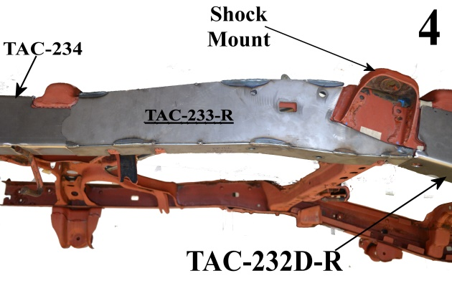
- Use welding clamps to close any gaps along the TAC-233. Tack weld the TAC-233 along the top and underside of frame, and space tack welds at least every 2 to 3 inches.
- Check all measurements to make sure the vehicle has stayed straight. Check the gap between bed and cab to make sure it is parallel. Then, weld all edges of the TAC-233 100% to the original frame.
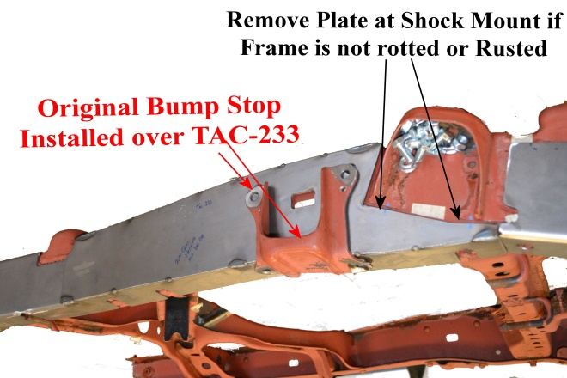
- For the Passenger Side: If you notched the TAC-233 around the shock mount, weld the edges of the frame kit to the frame.
- Re-install the bump stop back to the frame using the measurements taken in step 6. Bump stop can be welded to the frame or bolted onto the frame.
- Allow the welds to cool, then, rustproof the repaired area with rust inhibiting primer or undercoat.

We make the Kits, that Fit!

Note: Pictures in this Instruction sheet are for demonstrational purposes only. Some of the SafeTCap® Frame Repair kits shown in these pics are not fully welded and may have writing on them that is not for instructional use. These parts were for design and instructional use only. SafeTCap® Frame repair kits are shipped to customers fully welded and ready for install.

