Installation Instructions
IMPORTANT: Read and understand the “General Instructions for Installing SafeTCap® Frame Repair Kits” before you begin.
- Jack up the side of vehicle to be repaired and support it on properly rated jack stands. Make sure the center of vehicle is fully accessible.
- If you are repairing both sides, cut & repair one side at a time keeping one side assembled as a reference/measuring point.
- Remove any brackets, wiring, exhaust, and fuel/brake line clips from the frame and carefully move them out of the way noting their location.
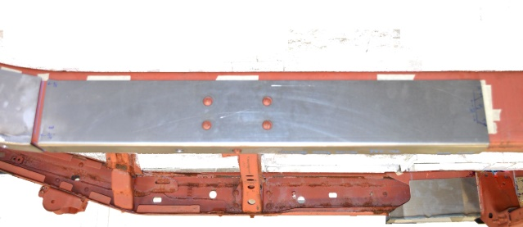
- Slide the SafeTCap® frame repair kit over the frame from underneath and make sure the rivet heads sit through the corresponding holes on the TAC-231. Mark the outline of the frame repair kit on the frame with a sharpie, paint marker or soapstone, then remove the frame kit.
- Prep the repair area for welding by grinding the frame down to clean, bare metal along the marked outline on both the outer, and underside of the frame. Remove any rust or debris from inside the frame using a needle scaler or grinder. Optional: You can coat the inside of the frame with a rust inhibitor, or rust preventative to prolong the life of the frame.
- Slide the frame repair kit back over the frame and use large C-clamps to firmly clamp TAC-231 to the frame. Use welding clamps to close any gaps on the sides. Then, tack weld the frame repair kit to your frame at all corners, and space tack welds at least every 2 to 3 inches.
- Check measurements and door gaps to make sure the vehicle has stayed straight, then weld all perimeter edges 100%.
- Allow the welds to cool then re-attach the fuel/brake lines and clips to the inside of the frame, rustproof the repaired area with a rust inhibiting primer or undercoat, then, re-attach any brackets or wiring back to the frame.
We make the Kits, that Fit!

