Installation Instructions
IMPORTANT: Read and understand the “General Instructions for Installing SafeTCap Frame Repair Kits” before you begin.
- Jack up the front & rear of vehicle and support it on properly rated jack stands. Make sure the center of vehicle is fully accessible.
- Remove the front sway bar from the frame by disconnecting the sway bar links, then unbolting the sway bar mounts on both driver and passenger side. Inspect sway bar bushings, replace if necessary.
- If you are repairing both sides, cut & repair one side at a time keeping one side assembled as a reference/measuring point.
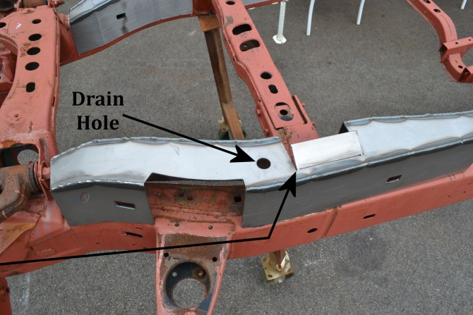
- Remove any brackets, wiring, exhaust, and fuel/brake line clips from the frame and carefully move them out of the way noting their location. You may need to drill holes in the frame kit to reattach fuel/brake line clips after installation.
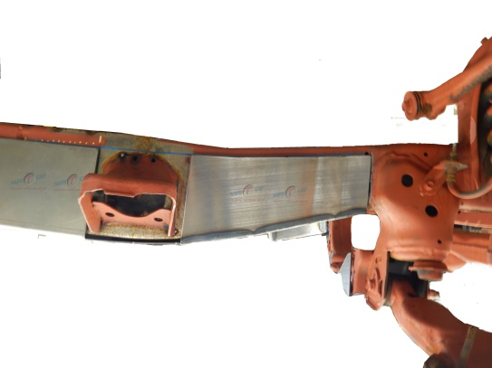
- The TAC-230 is notched to fit around the front cab mount. We’ve also notched the inside of the frame kit to fit around the transmission cross member. The cut lines on the underside of the TAC-230 should be finish cut and the tab bent down to match the angle of the cross member end so the frame kit fits tightly against underside of the frame.
Finish cut lines for Transmission Cross member tab and bend tab down.
- Note: It is best to remove the bottom ½” of the original frame within the covered area to allow the frame to drain properly through the SafeTCap® drain hole. Make sure to allow at least ¾” overlap where the frame kit meets the original frame.
- Slide the SafeTCap® frame repair kit over the frame from underneath and evenly space the frame kit around the cab mount and the Transmission cross member end. Mark the outline of the frame repair kit on the frame with a sharpie, paint marker or soapstone, then, remove the frame kit.
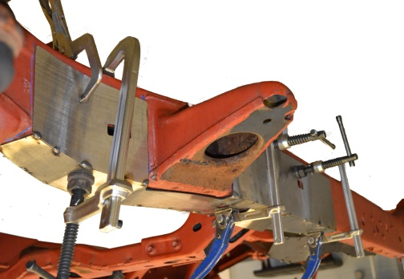
- Prep the repair area for welding by grinding the frame down to clean, bare metal along the marked outline on both the inner, outer, and underside of the frame. Remove any rust or debris from inside the frame using a needle scaler or grinder. Optional: You can coat the inside of the frame with a rust inhibitor, or rust preventative to prolong the life of the frame.
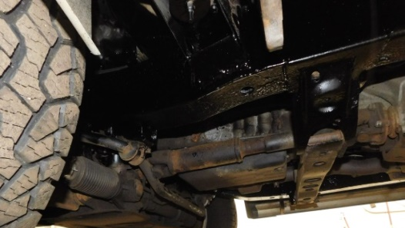
- Slide the frame repair kit back over the frame and use large C-clamps to firmly clamp TAC-230 to the frame. Use welding clamps to close any gaps on the sides. Then, tack weld the frame repair kit to your frame at all corners, and space tack welds at least every 2 to 3 inches.
- Check measurements and door gaps to make sure the vehicle has stayed straight, then, weld all perimeter edges 100%.
- Allow the welds to cool, then re-attach the brake lines and fuel lines to the inside of the frame, you may need to drill ¼” holes to attach the brake/fuel line clips to the frame.
- Rustproof the repaired area with a rust inhibiting primer or undercoat, then, re-attach any brackets or wiring back to the frame.

We make the Kits, that Fit!

Note: Pictures in this installation instruction sheet are for demonstration purposes only and may not actually reflect the identical make, model and year of the vehicle this frame kit was intended to fit.

