**Installation Instructions**

**IMPORTANT: Read and understand the “General Instructions for Installing SafeTCap® Frame Repair Kits” before you begin.**  \***ART-139HD** **fits the 3500HD with the single Fuel Tank ONLY!**

1. Prepare truck by running the fuel as low as possible in the tank to decrease the weight of the tank.
2. Support the truck on at least two heavy duty jack stands under the frame just before the rear axle, two additional jack stands on the frame after the rear axle will add extra stability and support.
3. Remove the two rear tires. Remove the fuel filler hose, a 5/16˝ socket is required.
4. Disconnect the Passenger side rear shock from the upper mount bracket.
5. Place a floor jack under the fuel tank to support it during removal.
6. Disconnect the two fuel lines. You will need a 3/8˝ and 5/16˝ “Quick Line Disconnect” available at any auto parts store. Clamp off or plug lines to avoid fuel leaks and fumes.
7. Unbolt the fuel tank straps holding the fuel tank in place.
8. Lower the fuel tank from the frame and move the fuel tank away from the vehicle. Cover the fuel tank with a fire proof blanket to protect it from welding or grinding sparks.
9. Mark the vertical center line of the original cross member on the outside face of both the left and right frame rails. Extend the line to the underside of each frame and up the inner side. (Illustrations – 1 & 2)
10. Make marks on the outside of your frame to ensure correct positioning of the new cross member by placing the ART-139 outside frame plates over the original cross member tube ends and tracing the end plates on the outside frame face. Its more efficient to grind any paint or debris from the inner and outer frame around the cross member before marking the outer plates location. Mark the area around the original cross tube to be cut on both the inside and outside of the two frame rails. (Illustrations – 1 & 2)
11. Next, remove the old cross member by cutting the frame around the 3˝ tube following your markings on all 4 frame faces; inside and outside on both sides of the frame.
12. Inspect your ART-139 repair kit and prepare to position it so that the shock mount is on the passenger side of the truck, on top of the tube and facing the rear bumper. The fuel tank mounts are facing down on the driver’s side of the truck. (Illustration – 3)
13. To test fit your ART-139, lift your cross member into position by sending the shock mount end over the driveshaft, then slide the loose inner mount plate onto the ART-139 until it’s against the upper shock mount. Make sure the pointed corner is oriented the same as the driver side inner mount plate.
14. Next slide the cross member through the passenger side inner frame towards the outside until the upper shock mount is against the inside of the frame.
15. 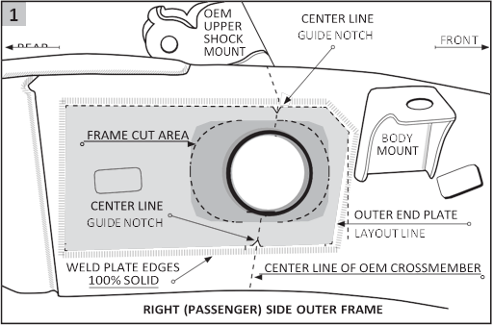Lifting the left side up, aligning it with the hole in the left inner frame, and slide it through the frame until the inner mount plate is flat against the truck frame. (Illustration – 3)
16. Place the outside end plate onto the cross member tube ends and clamp the entire assembly onto position by lining the plates up with the end plate outline and center line marks. (Illustration -1)
17. Check the fit, make sure shock mount and gas tank mounting brackets are positioned correctly.
18. 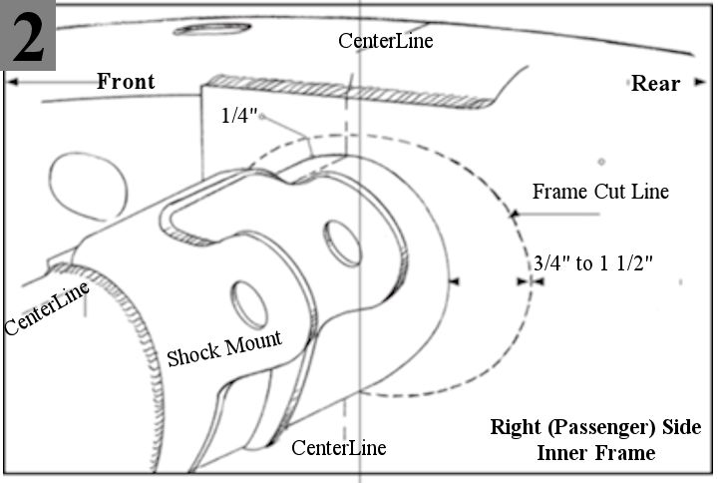**Important:** Brake lines and all wiring must route above the ART-139.
19. When satisfied with cross member position, tack weld the inner and outer frame plates to the frame and tube. Double check position, then weld entire perimeter of the inner and outer frame plates and tube.
20. Remove exhaust strap from the old cross tube and weld it on the new ART-139.
21. Check your welds for proper penetration.
22. Prime, paint, and/or rustproof your new ART-139 SafeTCap® Frame Repair Kit.
23. Reinstall the fuel tank, fuel lines, fuel filler hose, shocks and tires.
24. 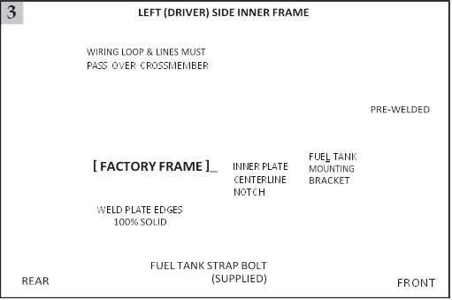Add Fuel to the fuel tank and start the engine to check for fuel leaks.
25. 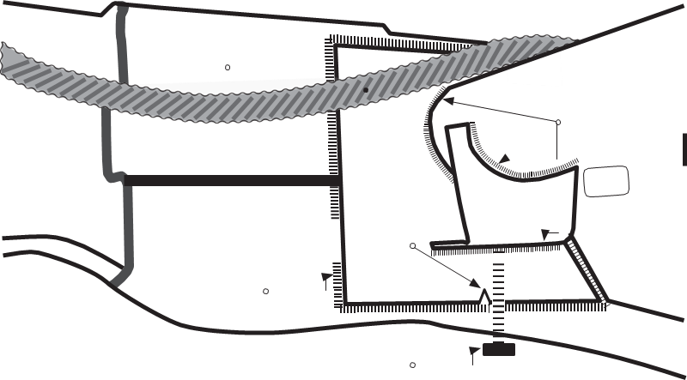Double check all bolts.
26. Remove jack stands and lower vehicle to ground and you are back on the road again!

***We make the Kits, that Fit!***