Installation Instructions
IMPORTANT: Read and understand the “General Instructions for Installing SafeTCap® Frame Repair Kits” before you begin installation. Make sure to disconnect battery.
- Jack up the front of the vehicle and use properly rated jack stands to safely support the frame allowing the front axle to hang free so the leaf springs are unloaded.
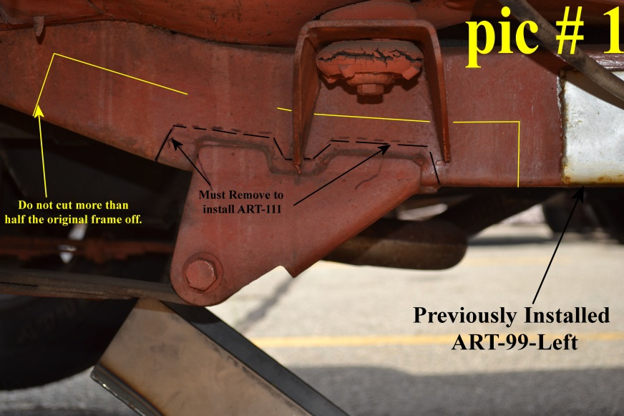
- If repairing both driver and passenger sides, install only one side at a time. Keeping one side intact as a reference.
- Unbolt the leaf spring from the mount and remove any brake lines or cables attached to the inside of the frame.
- Measure the lower spring mounts bolt hole center to a fixed point on the frame. Note: It is best to measure the front leaf spring mounts location using the forward shackle mounts bolt hole center. See PIC #2 below
- Cut the original spring mount from the frame using a plasma cutter or cut-off disc.
- OPTIONAL: the body mount bushing bolt from the mount, make sure to measure the height of the mount on the frame before removing it. Check the body mount bushing for cracks, splits or dry-rot, replace if necessary. PIC # 1 shows a dry-rotted bushing which needs to be replaced.
- Cut the body mount from the frame as close to the frame as possible, it must be welded back onto the frame after installing the ART-111.
- Slide the ART-111 up onto the frame from underneath and clamp onto the frame. Use the measurements taken in step # 4 to ensure the Art-111 is in the correct position.
- Mark the outline of the ART-111 onto the frame with a sharpie or paint pen on both inner and outer sides and bottom.
- Remove the ART-111 and cut off any rusted metal within the outline, Pic # 1 shows the minimum amount needed to remove (Black line) and the maximum amount of frame to remove (Yellow Line). SafeTCap® Frame Repair Kits should overlap the original frame at least ¾” inch all the way around in order to properly weld it to the frame.
- Grind the frame down to clean, bare metal all along the marked outline both inner and outer sides of the frame. You must have clean metal for the welds to penetrate properly.
- Grind the body mount to clean, bare metal where it meets the frame and make sure it will sit flush against the ART-111 so it can be welded to the frame after installing the frame section.
- Slide the ART-111 back onto the frame from underneath and clamp onto the frame. Use measurements taken in step # 4 to ensure it’s in the proper position. Close any gaps along the upper edge of the ART-111 with welding clamps. Also, make sure the ART-111 is clamped firmly to the bottom of the original frame, any gaps between the bottom of the original frame and the bottom of the frame kit usually means the frame kit isn’t properly in place or you need to remove more of the bottom of the original frame.
- Tack weld the ART-111 to the frame working from front to back and bottom to top on both inside and outside of the frame, space tack welds at least every 3 to 4 inches.
- Test fit the leaf spring by jacking up the front axle until the leaf spring bushing eye is in between the ART-111 spring mount and install the leaf spring bolt and nut. Don’t fully torque until after the ART-111 is fully welded, cooled off, and rustproofed.
- Re-install the body mount and bushings, Install the body mount bolt through the lower bushing then body mounting hole then upper bushing and screw bolt to the body. Tighten firmly, ensure proper position with measurements taken in step # 6.
- Tack weld the body mount to the ART-111 making sure the body mount is at a perfect right angle (90°) to the frame. Also make sure the bolt is in the center of the body mount hole. You may need to remove no more than .125” (1/8”) from the body mount where it meets the frame due to the thickness of the ART-111.
- Weld the ART-111 to the frame using 2” to 3” welds every 4” inches on both upper inside and outside of the frame until its 100% fully welded. Then weld the body mount to the ART-111 and frame. NOTE: Remove the body mount bushings before fully welding to make sure it doesn’t get damaged or melted from the excessive heat from the welds.
- Allow the ART-111 to cool off, then rustproof the repair area.
- Reconnect the body mount bushings and tighten to 40-60 ft-lbs of torque, and the leaf spring to the new spring mount. Leaf spring should be tightened to 105 ft-lb of torque.
- Re-connect any lines or cables back to the frame. Remove jack stands and lower Jeep to the ground. Double check all suspension and re-connect battery negative terminal.
- Test drive then double check suspension components.
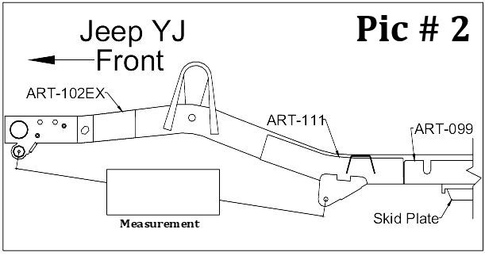
We Make the Kits, that Fit!

