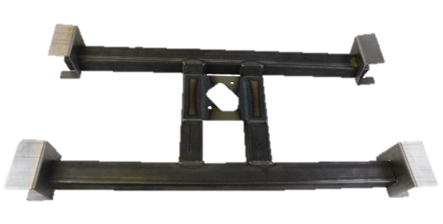
Installation Instructions
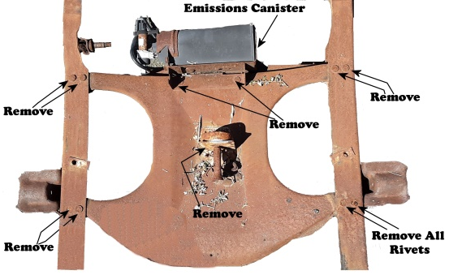
IMPORTANT: Read and understand the “General Instructions for Installing SafeTCap® Frame Repair Kits” before you begin.
- Jack up the rear of the vehicle with a hyd. Jack and use properly rated jack stands to support the rear axle.
- Remove the spare tire, the rear bumper, and the rear 2 bed mount bolts. *Removing the pick-up trucks bed is optional, but we suggest leaving the bed attached to the frame as it will keep the frame rails straight.
- Cut all rivets and/or bolts holding the original spare tire mount to the frame, then, remove the cross member from between the frame rails.
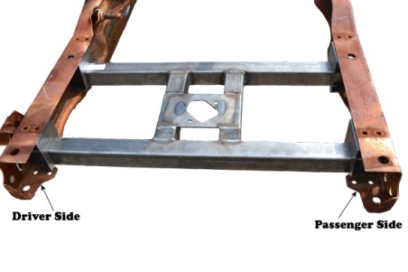
- Detach the spare tire hoisting mechanism from the original cross member, and remove the emissions canister from the cross member if its attached.
- Test fit the ART-151 by sliding it between the frame rails from the rear. Make sure to remove the ½” hex cap screw from the ART-151 before test fitting. The ½” weld nuts should end up in the rear lower end of the ART-151 to bolt the rear bumper onto the frame.
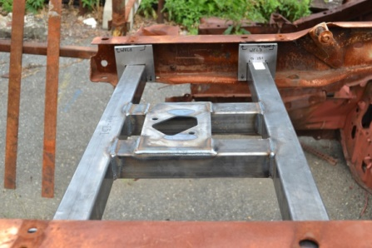
- Attach each of the 4 frame plates to each leg of the cross member and slide them against the inside of the frame rails.
- Mark the locations of the frame plates on the frame with a paint pen, marker, or soapstone.
- Remove the ART-151 and frame plates from the frame and grind the marked areas down to clean bare metal. Use a needle scaler to remove any rust buildup that may be inside the frame rails.
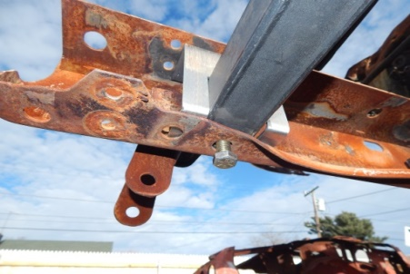
- Once all 4 marked areas are rust free, re-install the ART-151 and all 4 frame plates, screw in the new rear bumper bolts to the ART-151, this will keep the ART-151 in place while welding.
- Ensure the ART-151 is in the correct location, then, tack weld all 4 frame plates to the frame and cross member.
- Double check the ART-151’s placement on the frame, then, weld all frame plates to the frame then to the ART-151.
- Allow the ART-151 welds to cool off, and coat the repaired area and the new cross member with either primer or a rust protective coating.
- Connect the spare tire hoisting mechanism to the ART-151 and bolt it in.
- Reinstall the rear 2 bed bolts and the rear bumper.
- If you removed the emissions canister from your original spare tire cross member, attach the emissions canister to the ART-151. You may need to either, drill and bolt the emissions canister to the new cross member, or tack weld the canisters bracket to the ART-151. Self-tapping screws is another option.
- Double check all bolts are tight and wiring is secured to the cross member and the frame, and re-connect your spare tire to the cross member.
- You’re done!

We Make the Kits, that Fit!
8

