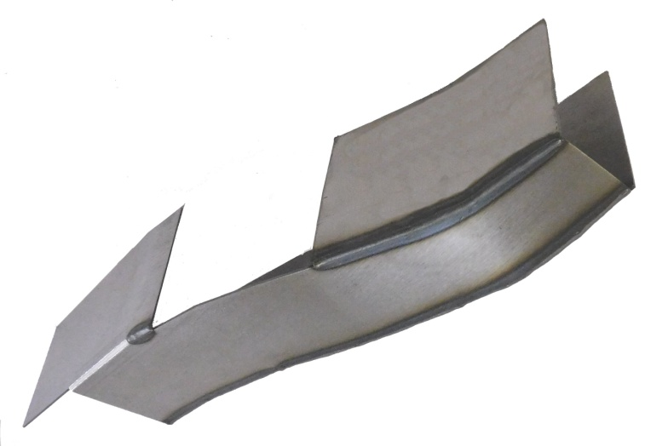
Installation Instructions
IMPORTANT: Read and understand the “General Instructions for Installing SafeTCap Frame Repair Kits” before you begin.
- Jack up the front of vehicle and support it on properly rated jack stands. Place jack stands under the frame, just behind the transmission cross member and under the frame forward the front wheels.
ART-200-R

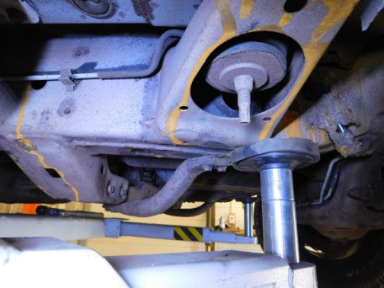
- If you are repairing both sides, cut & repair one side at a time, keep one side assembled and intact as a reference/measuring point.

- Un-bolt the support bar from the underside of the front frame and the transmission cross member.

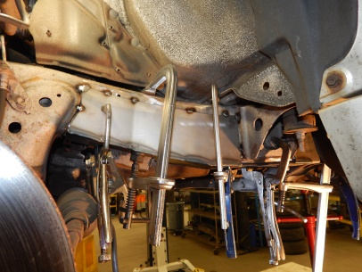
- Remove any brackets, wiring, and/or Hydraulic/Fuel lines from the frame and carefully move them out of the way. Measure down from the top of the frame to the holes in the frame for holding the wire clips, or hyd/fuel line clips. Take note of these measurements, you will need to drill these holes into the ART-200 to remount the wire/line clips after installation.

- Slide the ART-200 frame repair kit over the frame from underneath and make sure the notch around the cab mount is evenly spaced. Mark the outline of the frame repair kit on your frame with a marker or paint pen then remove the frame kit.

- Grind the frame down to bare, clean metal all along the marked outline of the frame repair kit.

- Slide the ART-200 back onto the frame from underneath. Firmly clamp the ART-200 to the frame. Use vise grip clamps to close any gaps on the sides, then tack weld the frame repair kit to your frame.

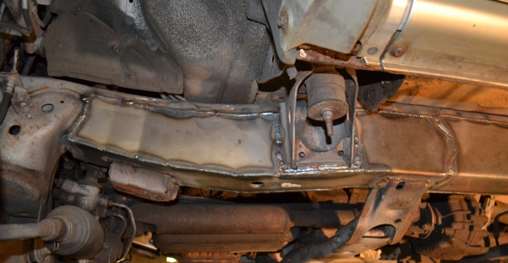
- If you’re installing additional frame repair kits, test fit those kits now to make sure everything will fit together properly.

- Check measurements and door gaps to make sure the vehicle has stayed straight, then, weld all edges 100%. If you’re installing additional frame repair kits, do not weld the ends yet.
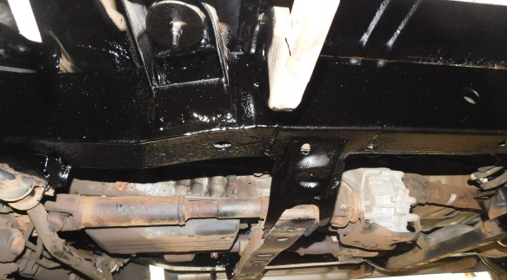
- Drill any holes for wire clips, or hyd line clips in the frame repair kit using the measurements taken earlier.

- Prime, paint or undercoat the repaired area, then re-attach any brackets, wiring and/or brake lines back to the frame and make sure to secure them.

We Make the Kits, that Fit!

Note: Some pictures used in this installation instruction are for demonstrational purposes and may not actually depict the exact model vehicle, but closely resembles the area of the frame being repaired.

8
7

