Installation Instructions
IMPORTANT: Read and understand the “General Instructions for Installing SafeTCap® Frame Repair Kits” before you begin installation.
- Jack up the rear of the vehicle and use properly rated jack stands to safely support the frame support the frame allowing the rear end to hang free so the rear suspension is unloaded.
- If repairing both driver and passenger sides, install only one side at a time. Keeping one side intact as a reference.
- Remove the fuel tank and store it safely away from any welding. Cover the fuel lines and keep them away from any sparks or flames.
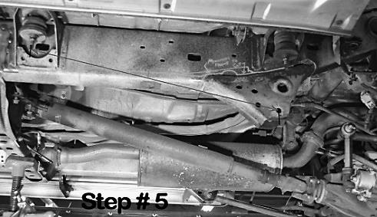
- Disconnect the lower control arm from the frame and any brake lines or cables attached to the inside of the frame.
- Measure the lower control arm mounts bolt hole center to a fixed point on the frame. Note: The nearest body mount bolt just forward of the control arm mount is a good measuring point. Be precise, you will need this measurement to properly align the ART-218 frame repair kit.
- Cut the original control arm mount from the frame using a plasma cutter or cut-off disc.
- The ART-218 has a removable plate for the body mount above the control arm mount. . Check the integrity of the frame behind the body mount. If the frame is solid, this plate can be removed by continuing the cut lines and the ART-218 can be installed without disturbing the body mount.
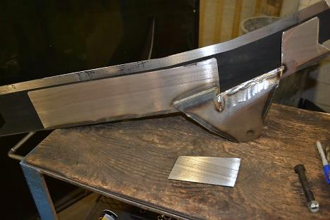
- Once original control arm mount is removed from the frame, test fit your ART-218 by sliding it up over the frame. Using large C-clamps, clamp the frame kit firmly up against the bottom of the frame. Using the measurement taken in step # 5, make sure your ART-218’s control arm mount is in the proper position.
- Mark the entire outline of the ART-218 on the frame with a paint pen, or marker, then remove the ART-218 frame kit.
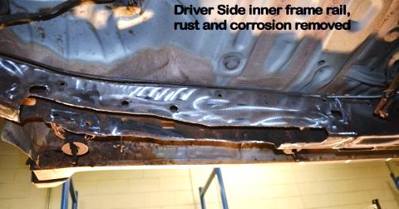
- Using the marked outline as a guide, we suggest removing at least 1 inch of the bottom of the frame. Leave at least 2 inches of frame from the forward marked line and 2 inches from the rear marked line so the ART-218 overlaps the original frame.
- Grind the frame down to clean, bare metal along the marked outline.
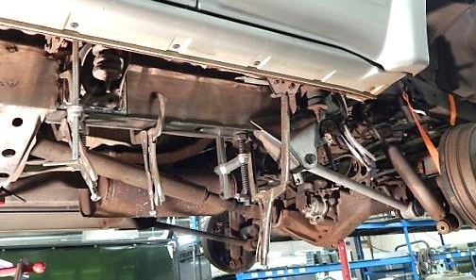
- Slide the ART-218 back onto the frame, make sure it’s in the correct position using measurements taken in step # 5, and clamp firmly onto the frame. Use vise-clamps and large C-clamps and clamp the ART-218 to the original frame. Tighten clamps to close any gaps, then check measurements.
- Tack weld the ART-218 to the frame along the entire perimeter spacing tack welds at least every 4 inches.
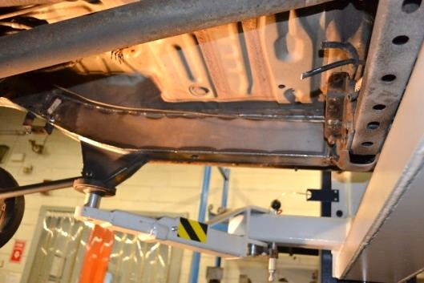
- Install the lower control arm to the ART-218 mount first, then to the rear axle. Torque the control arm Bolts to 96ft.lbs, while holding the nut with a wrench. Hint: We use a ratchet strap hooked to a cross member just forward of the rear axle, then hooked to the rear axle lower shock mount, to pull the rear end forward in order to bolt on the lower control arm.
- Weld your ART-218 to the original frame, using 4 inch welds every 4 inches. Move around the entire perimeter of the ART-218 both inside and outside so you don’t heat up any one area more than another.
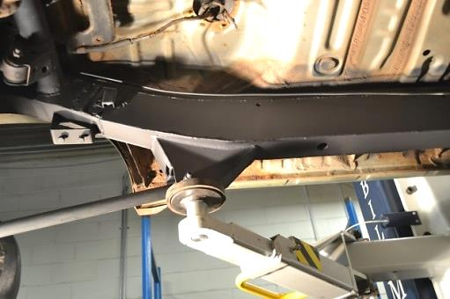
- Once the frame repair kit has cooled from welding, you will need to drill 2 or 3, 5/16”Ø holes on the inner side of the frame repair section to secure the brake line clips removed earlier.
- Re-Attach the metal fuel tank spacer bracket to the inside frame either by tack weld, or self tapping screw.
- Coat your frame repair section with a rust inhibiting primer or paint, or undercoating.
- Re-Attach brake lines to the inside frame.
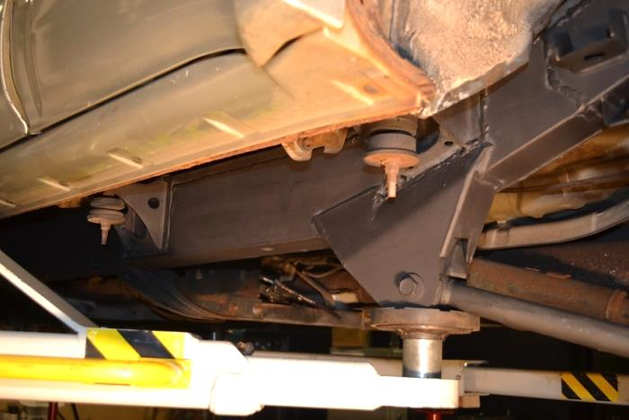
- Reinstall fuel tank and all fuel lines.
- Lower vehicle to the ground.
- Re-connect battery.

We Make the Kits, that Fit!

