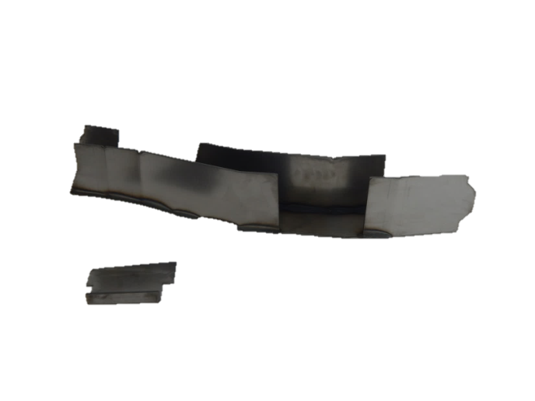
Installation Instructions
IMPORTANT: Read and understand the “General Instructions for Installing SafeTCap Frame Repair Kits” before you begin.
- Jack up the front & rear of vehicle and support it on properly rated jack stands. Make sure the center of vehicle is fully accessible.
ART-216-L
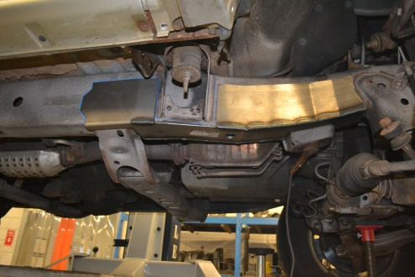
- Remove the front sway bar from the frame by disconnecting the sway bar links, then unbolting the sway bar mounts on both driver and passenger side. Inspect sway bar bushings, replace if necessary.
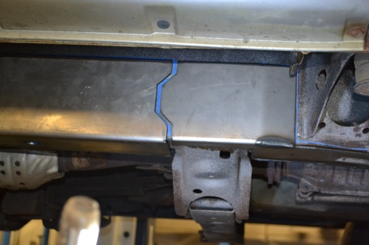
- If you are repairing both sides, cut & repair one side at a time keeping one side assembled as a reference/measuring point.
- Remove any brackets, wiring, exhaust, and fuel/brake lines from the frame and move them out of the way noting their location. You may need to drill holes in the frame kit to reattach fuel/brake line clips after installation.
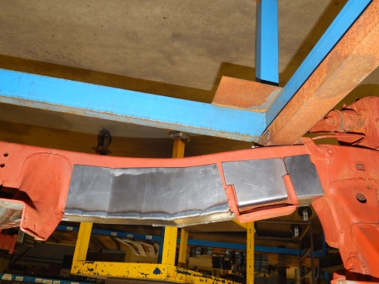
- Slide the SafeTCap® frame repair kit over the frame from underneath and evenly space the frame kit around the cab mount. Mark the outline of the frame repair kit on the frame with a sharpie, paint marker or soapstone, then, remove the frame kit.
- Prep the repair area for welding by grinding the frame down to clean, bare metal along the marked outline on both the inner and outer sides of the frame.

- This frame kit comes with a plate for the frame above the sway bar mount. This plate should be installed before the ART-216 is welded to the frame.
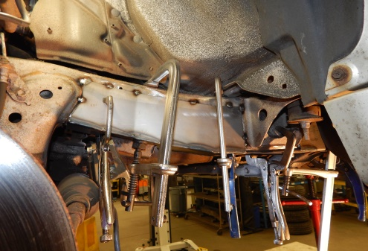
- Slide the frame repair kit back over the frame and use large C-clamps to make sure any gaps are closed, then, tack weld the frame repair kit to your frame. Tackweld all corners, and then, space tack welds at least every 2 to 3 inches.

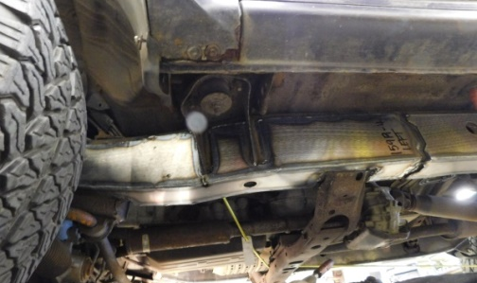
- If you’re installing additional frame repair kits, test fit those kits now to make sure everything will fit together properly.

- Check measurements and door gaps to make sure the vehicle has stayed straight, then, weld all edges 100%. If you’re installing additional frame repair kits, do not weld the ends yet.
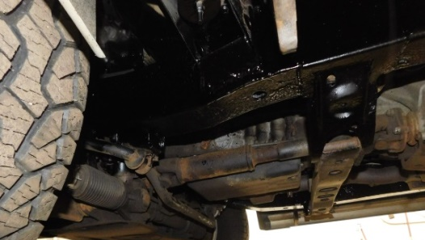
- Prime and/or paint the repaired area, then re-attach any brackets, wiring and/or brake lines back to the frame and make sure to secure them.

We make the Kits, that Fit!

Note: Pictures in this installation instruction sheet are for demonstration purposes only and may not actually reflect the identical make, model and year of the vehicle you are working on.

