Installation Instructions
IMPORTANT: Read and understand the “General Instructions for Installing SafeTCap Frame Repair Kits” before you begin.
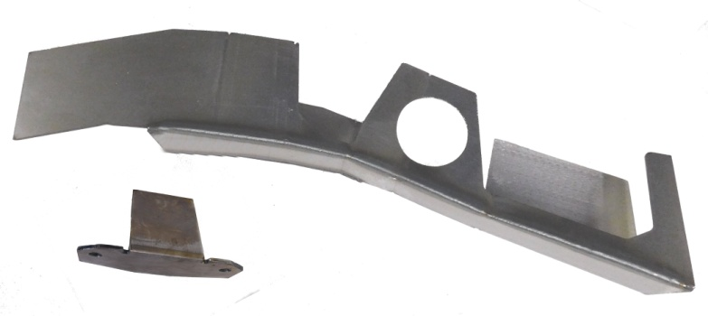
- Jack up the front & rear of vehicle and support it on properly rated jack stands. Place rear jack stands under frame, behind rear axle. Make sure the center of vehicle is fully accessible.

- If you are repairing both sides, cut & repair one side at a time keeping one side assembled as a reference/measuring point.
ART-203-R
4
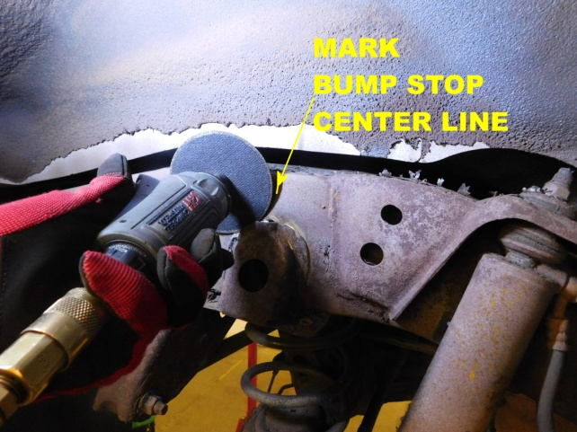
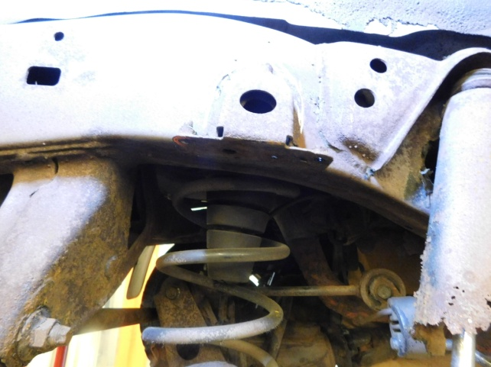
3

Mark the centerline of bump stop bracket on upper frame and cut off.
Support rear axle and remove wheel.

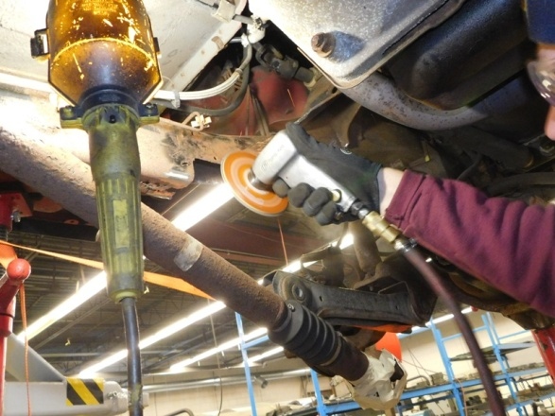
5
6
8
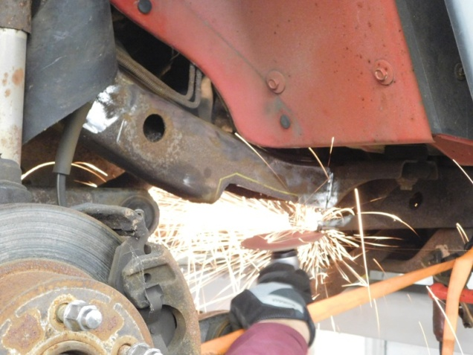

Cut away the rusted area using a plasma cutter, reciprocating saw or torch.
Position the kit into place and roughly mark the outline. Remove kit and grind the frame down to clean metal.

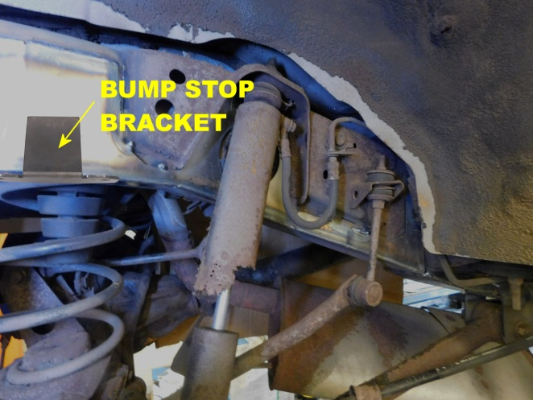
8
7
8
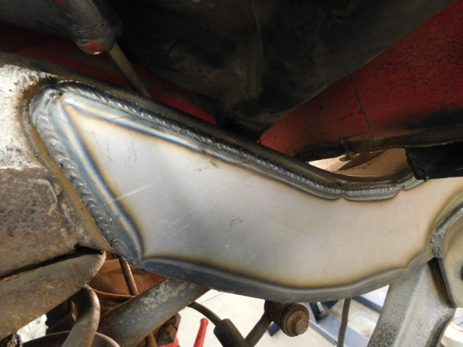

Slide kit over frame and clamp. Tack weld kit in place. Position bump stop bracket and tack in place. If you are installing additional kits to frame, test-fit those now to make sure they all fit together properly.

Double check all measurements and check door gaps to make sure vehicle stayed straight, then weld all edges 100% solid. If you are adding additional kits, don’t weld the ends yet.

9
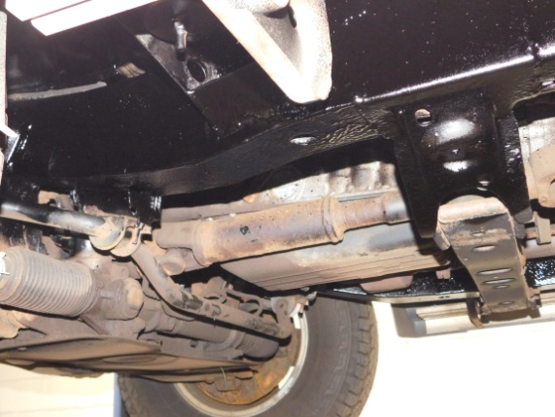
Prime and paint the repaired area. Use self-tapping screws to remount the brackets that were removed.

Note: Numbered pictures in this installation instruction sheet are for demonstration purposes only and may not actually reflect the identical make, model and year of the vehicle you are working on.

