Installation Instructions
IMPORTANT: Read and understand the “General Instructions for Installing SafeTCap Frame Repair Kits” before you begin.
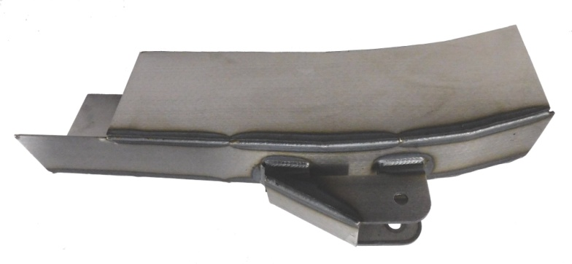
- Jack up the front & rear of vehicle and support it on properly rated jack stands. Place rear jack stands under frame, behind rear axle. Make sure the center of vehicle is fully accessible.

- If you are repairing both sides, cut & repair one side at a time keeping one side assembled as a reference/measuring point.
ART-202-R
4
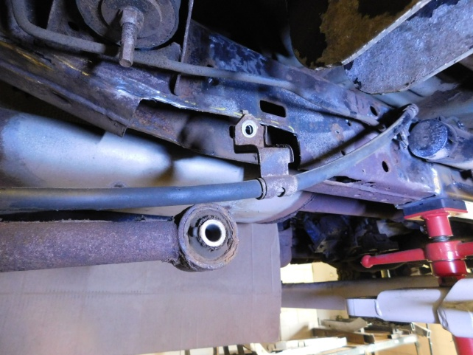
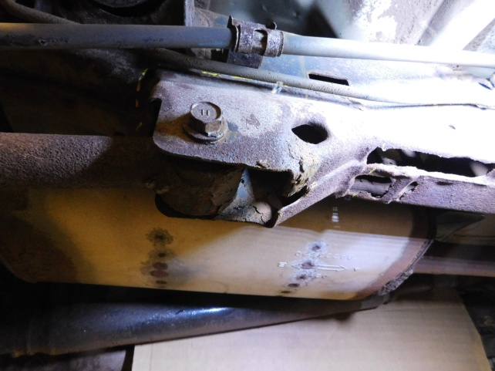
3

Support rear axle and unbolt lower trailing arm at the frame end and swing out of the way. Measure from the trailing arm bracket bolt hole to two fixed reference points for locating new kit later.

Cut lower trailing arm bracket off.

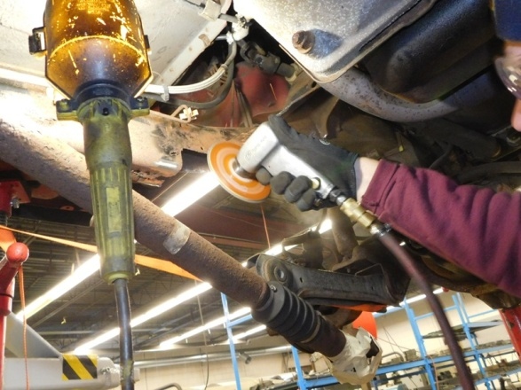
5
6
8
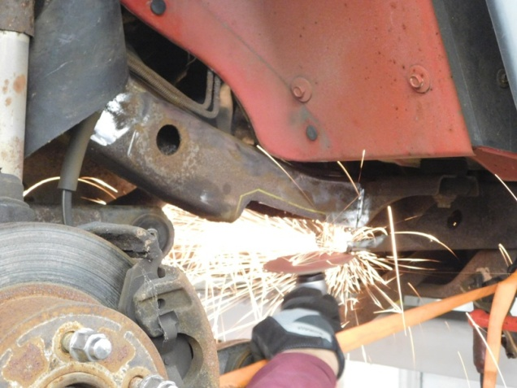

Cut away the rusted area using a plasma cutter, reciprocating saw or torch.
Position the kit into place and roughly mark the outline. Remove kit and grind the frame down to clean metal.

8
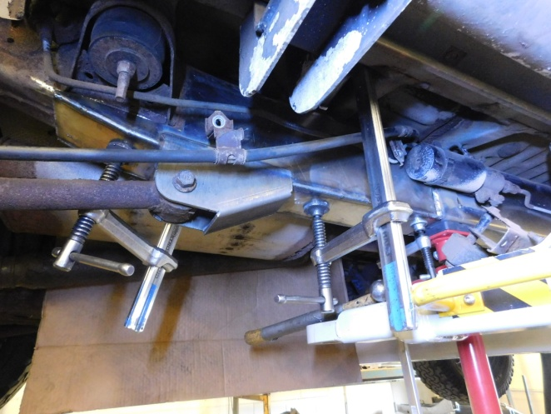
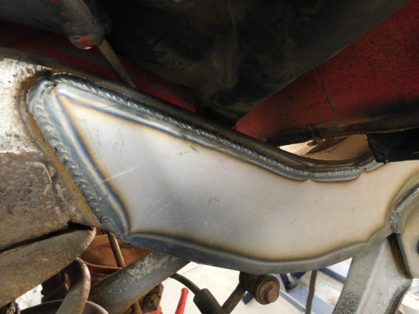
7

Double check all measurements and check door gaps to make sure vehicle stayed straight, then weld all edges 100% solid. If you are adding additional kits, don’t weld the ends yet.

Slide kit over frame, clamp and bolt in lower trailing arm. Check measurements taken earlier to trailing arm bracket. Tack weld kit in place. If you are installing additional kits to frame, test-fit those now to make sure they all fit together properly.

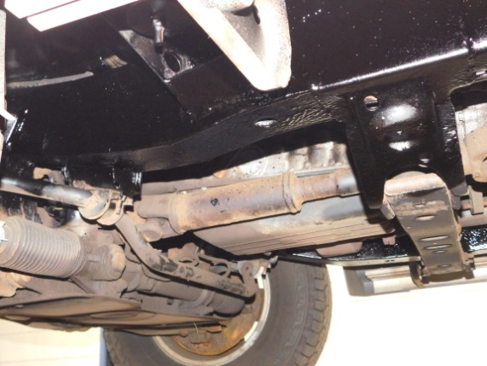
9
Prime and paint the repaired area. Use self-tapping screws to remount the brackets that were removed.

Note: Pictures in this installation instruction sheet are for demonstration purposes only and may not actually reflect the identical make, model and year of the vehicle you are working on.

