Installation Instructions
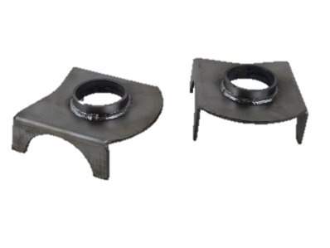
IMPORTANT: Read and understand the “General Instructions for Installing SafeTCap® Frame Repair Kits” before you begin. If repairing both sides, make sure to install only one side at a time.
- Jack up the vehicle and allow the rear end to hang free.
- Remove both rear shocks, this allows the rear axle to hang lower, which will allow you to remove the coil spring.
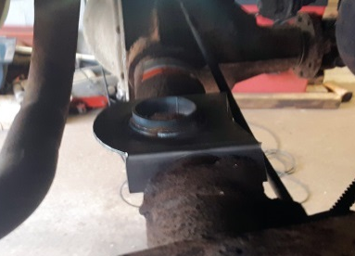
- Measure the placement and angle of the original mount, then remove the original mount as close to the axle as possible, and grind the surface down to clean metal for a good weld.
- Place the new ART-212 on the rear axle using the measurements taken in previous step, make sure the center of the ART-212 is lined up to the center of the upper spring mount.
- Tack weld the ART-212 to the axle. Then, check measurements and placement.
- Weld the ART-212 to the rear axle. Try not to overheat the axle.
- Reinstall the coil spring/air bag, make sure it goes in the same way it came out. For Air suspension, See Step #10 *.
- Jack up the rear end to re-install the rear shocks.
- Coat the spring mount and rear axle with a rust proofing primer.
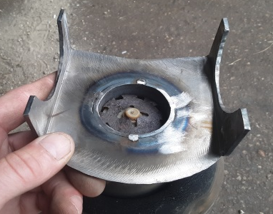
For installing this spring mount with Air Bag suspension
- Follow above steps. Protect the air bags from welding spatter during install. *When reassembling the suspension, make sure the metal clip is snapped firmly to the center pin under the bottom of the air bag. Place the air bag on the new mount, the metal clip should snap into the center tube, securing it to the spring mount.

We Make the kits that fit!
8
7

