Installation Instructions
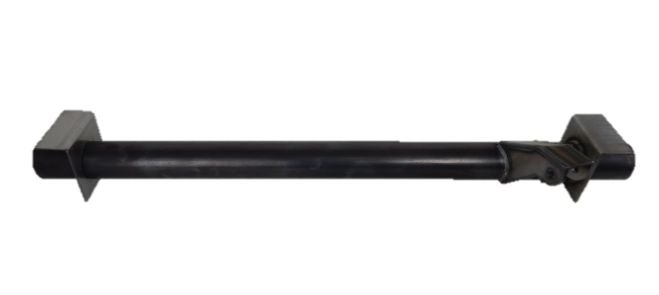
IMPORTANT: Read and understand the “General Instructions for Installing Safe T Cap® Frame Repair Kits” before you begin. Support the truck on two heavy duty jack stands, create as much room as possible to work safely. Level frame left to right. Leave the bed on.
- Remove both rear tires, and the spare tire.
ART-140-2
- Disconnect the driver side shock from the shock mount on the rear cross member.
- If your vehicle has an exhaust hanger welded to the rear cross member, carefully cut off the exhaust hanger as close to the cross tube as possible, save for reuse with rubber bushing.
- Unbolt the grounding wire from the spare tire mount plate.
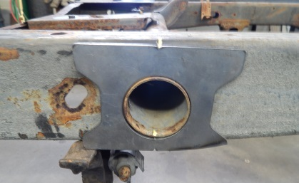
- Carefully cut the weld connecting the spare tire mounting plate to the rear cross member.
- Use the ART-140-2 outer plates to make location marks on the outside of the frame.
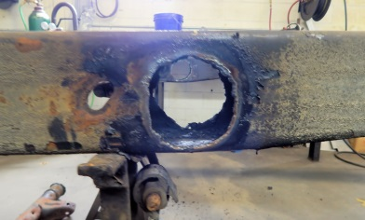
- To remove the original cross member, cut the frame a ¼” away from the tube all the way around, on both driver and passenger sides, and both inner frame and outer frame.
- Remove the original cross member from the frame.
- Grind the frame down to clean metal on both sides, inner and outer, be careful not to remove the location lines from step 6.
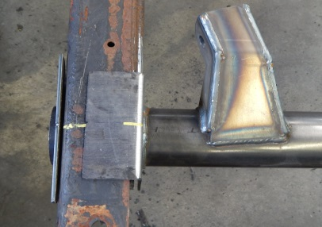
- Put the passenger side inner plate onto the ART-140-2, then slide the ART-140-2 through the inner hole on the passenger side frame, enough for the other end of the cross member to go through the inner hole on the drivers side frame, until the pre-welded driver side plate is in position firmly against the driver side inner frame.
- Using the location marks on the frame from step 6, line up the center notches on the pre-welded, driver side inner plate to the location marks and clamp the cross member to the frame.
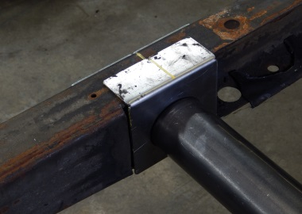
- Slide the loose plate to the passenger side inner frame and line up the center notches to the location marks, and clamp the plate to the frame.
- Check the location of the shock mount and overall alignment of the cross member.
- Once satisfied with placement of the ART-140-2, put the outer plates on each end of the cross member tube and tack weld to both frame and tube.
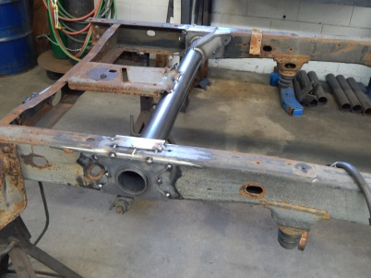
- Tack weld both inner plates to the frame and tack weld the passenger side inner plate to the tube.
- Re-check cross member placement and ensure all plates line up to the location marks.
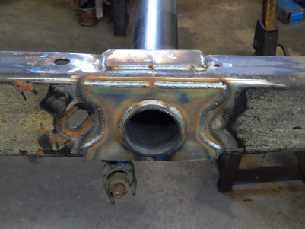
- Once satisfied, weld inner and outer plates to the frame and tube completely.
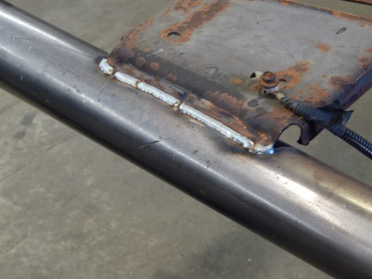
- Weld the spare tire mounting plate and exhaust hanger(If any) to the cross member.
- Re-attach ground wire to the spare tire mounting plate.
- Paint repair area and the new ART-140-2 cross member.
- Remount shocks, spare tire and both rear tires.
- Lower truck to the ground and you’re on the road again.

We Make the Kits, that Fit!

8
7

