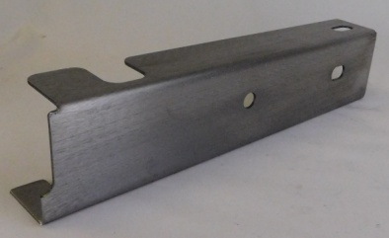
Installation Instructions IMPORTANT: Read and understand the “General Instructions for Installing SafeTCap Frame Repair Kits” before you begin.

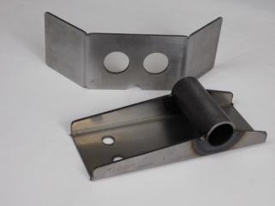
- You do not have to remove bed, but it is easier for access. If you are reusing your shackle mount, disregard instructions for TAC-164.
TAC-155-2
- You will have to remove a tow bar bracket if attached to that section of frame.
- Remove the rear bumper and mounting brackets.
- Unbolt the 2 rear bed bolts on each side, this will allow sliding the kit into place much easier.
TAC-164
- Measure distance from front leaf spring eye to rear leaf spring eye and record this measurement.
7
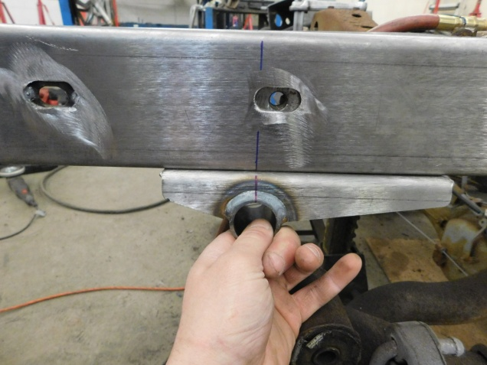
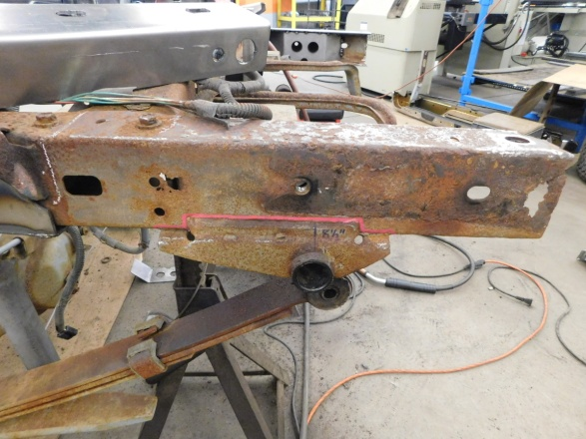
6
Remove leaf spring bracket, leaving as much of the frame as possible. If reusing bracket, use care when cutting.
Dry fit frame cap and mark where to grind frame for welding. Prep frame, then reinstall frame cap and clamp in place. Mark centerline of leaf spring shackle mount using measurement from step 5.
Figure A

8
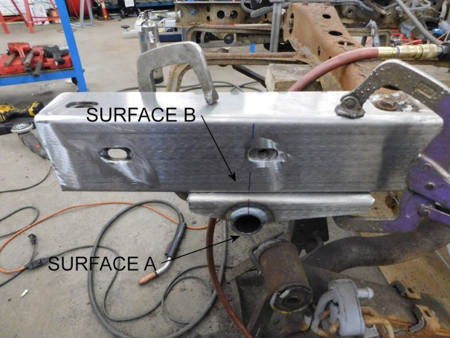
Position shackle mount on centerline mark. The outside edge of tube (surface A) is ½” off the new frame cap (surface B). The long side of bracket goes toward the front of vehicle.

5
- Test fit bumper brackets and bumper alignment.
- When satisfied with fit, tack weld the TAC-155-2 to the truck frame.
- Check the side to side alignment of the leaf spring shackle mount TAC-164. Shackles should be centered on the bushing tube. Do not insert bushings prior to welding.
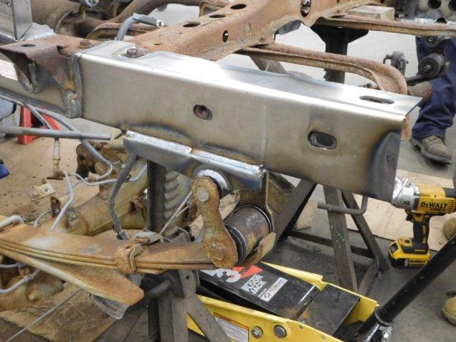
- Remove bumper and brackets.
13
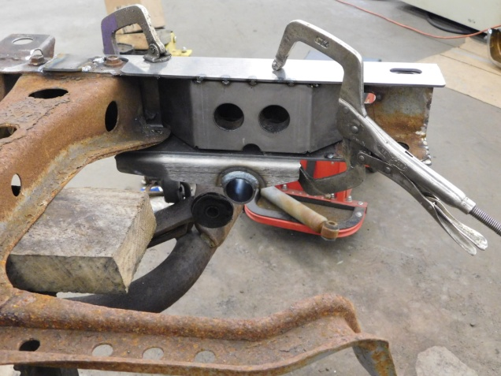
Weld pieces solid all around. Paint repaired area. Reinstall bumper and leaf spring shackles. Reattach bed to frame.
Slide new part in from rear as shown.

