Installation Instructions
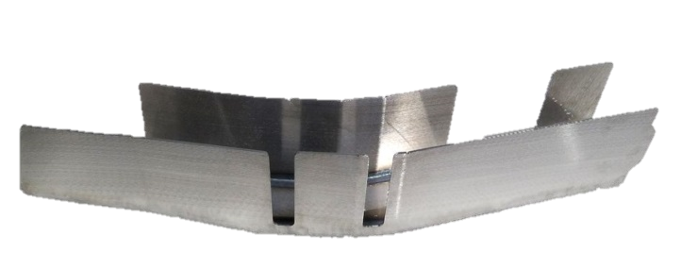
IMPORTANT: Read and understand the “General Instructions for Installing SafeTCap Frame Repair Kits” before you begin.
- Jack up the front & rear of vehicle and support it on properly rated jack stands. Place rear jack stands under frame, behind rear axle. Make sure the center of vehicle is fully accessible.
TAC-159R-4-R

- If you are repairing both sides, cut & repair one side at a time keeping one side assembled as a reference/measuring point.

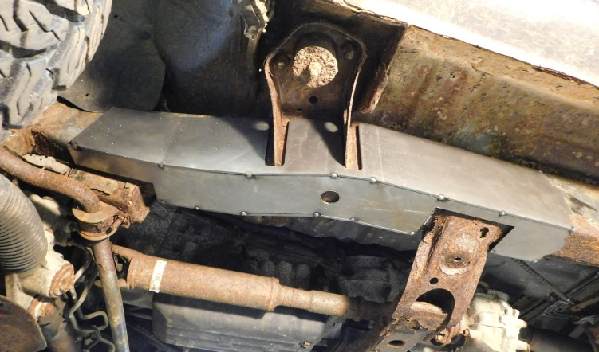
- Remove any brackets, wiring, and/or lines from the frame and move them out of the way.
- Slide the frame repair kit over the frame and make sure the gaps between the cab mount is evenly spaced. Mark the outline of the frame repair kit on your frame and remove the frame kit.

- Grind the frame down to clean metal all along the marked outline of the frame repair kit.

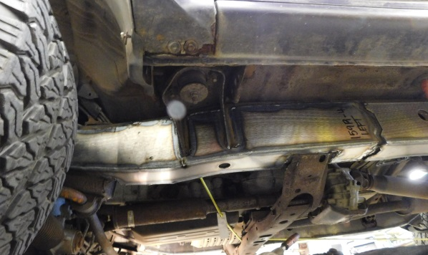
- Slide the frame repair kit back over the frame and clamp into place, make sure close any gaps then tack weld frame repair kit to your frame.

- If you’re installing additional frame repair kits, test fit those kits now to make sure everything will fit together properly.

- Check measurements and door gaps to make sure the vehicle has stayed straight, then, weld all edges 100%. If you’re installing additional frame repair kits, do not weld the ends yet.
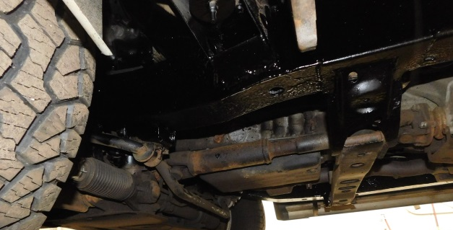
- Prime and/or paint the repaired area, then re-attach any brackets, wiring and/or brake lines back to the frame and make sure to secure them.

We Make it Easy, to make it Safe!

