Installation Instructions
IMPORTANT: Read and understand the “General Instructions for
Installing SafeTCap Frame Repair Kits” before you begin.
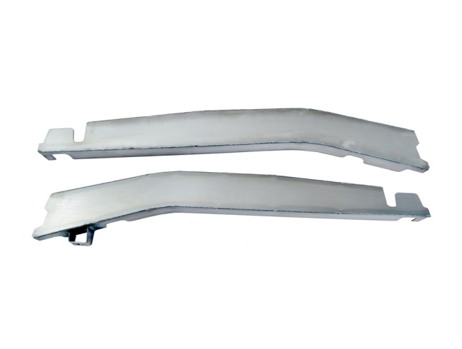
6) Remove the bump stop, save it to reinstall after the repair is complete.

7) The TAC-156U is a “C” shaped cap which can go directly over your frame from the outside without any removal of the damaged area.
8) Place the Safe T Cap® TAC-156U over your frame and mark the Position
9) Remove the TAC-156U and grind the area to be welded down to clean, Bare Metal.
10) Place the Safe T Cap® back into position and tack weld in place. If you have removed the bed, it is a good idea to place it back on the frame temporarily to insure everything lines up before you weld the repair solid.

11) If satisfied with the fit , weld the new repair all around.

12) Reattach bump stop.

1) Run the fuel level down to almost empty to make the removal of the fuel tank easier.

2) Determine if your frame is strong enough to withstand the vehicle being lifted. Tacoma’s with rust weakened frames have been known to jackknife while being lifted. Look for frame cracks that extend from the top to the bottom of the frame and rot holes that take out a major portion of the frame side.

3) If you are repairing both sides of your vehicle, work on only one side at a time. This will make it easier to stabilize the frame when both sides are weakened from rust or stress cracks.

4) This Safe T Cap® kit is designed to be installed with the bed left on. This helps to stabilize the frame. If you decide to remove the bed, close observation will insure the frame doesn’t twist, or become fixed in a bent position. Reinforcement may be needed, such as angle iron temporarily tack welded in key places to maintain dimensional stability.

5) Jack both rear wheels off the ground until you have enough clearance to remove the fuel tank from beneath the truck. Place two jack stands in front of the rear forward spring mounts and two additional stands behind the repair area. An additional jack under the rear axle is recommended.

Installation Instructions
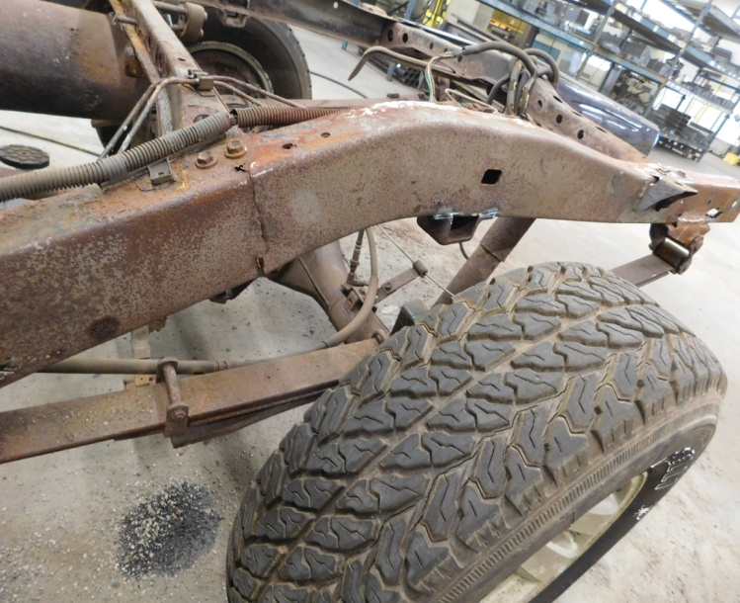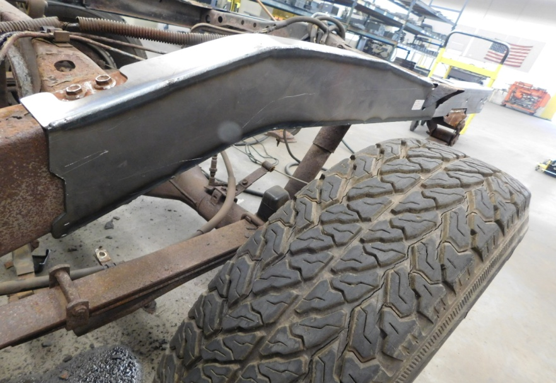

Before (driver side) After (driver side)
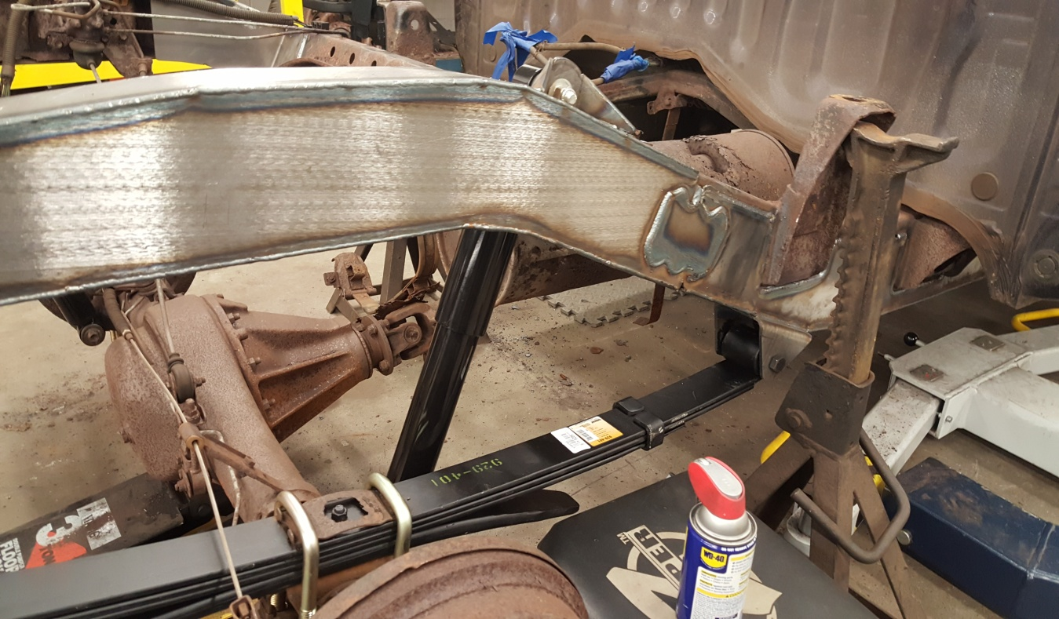
Passenger side (shows handy plate)

