**Installation Instructions**

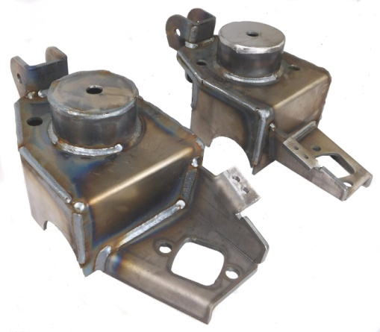**IMPORTANT: Read and understand the “General Instructions for Installing SafeTCap Frame Repair Kits” before you begin.**

1. Jack up the front of vehicle and support it on properly rated jack stands under frame. Make sure the front of vehicle is fully accessible.
2. If you are repairing both sides, **cut & repair one side at a time** keeping one side assembled as a reference/measuring point.

ART-210-S

4

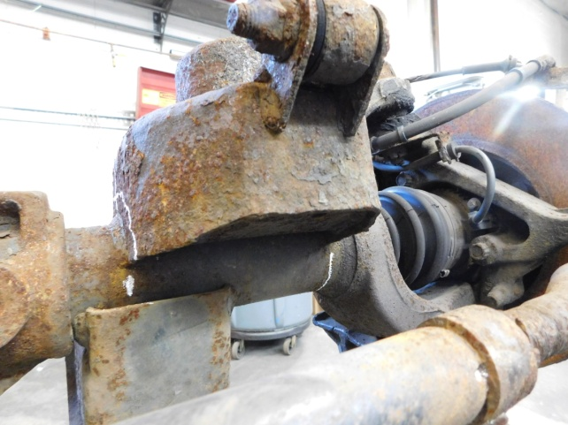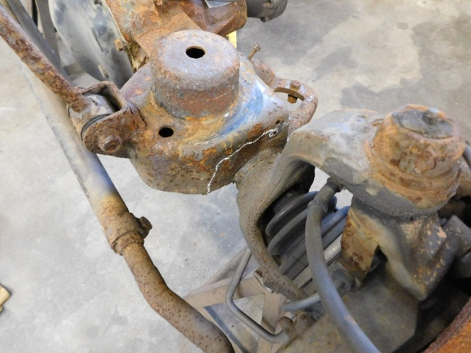

3

Jack up front axle and unbolt shock, track bar (if doing PS) and sway bar at axle end and swing out of the way. Both sides of sway bar must be unbolted to move out of way.

Unbolt brackets for brake lines and move aside.

Lower front axle enough to remove coil spring.

Mark location of existing bracket on axle tube.

6

5

8

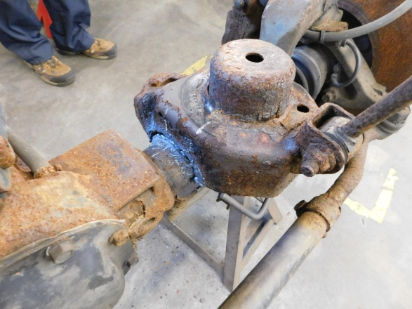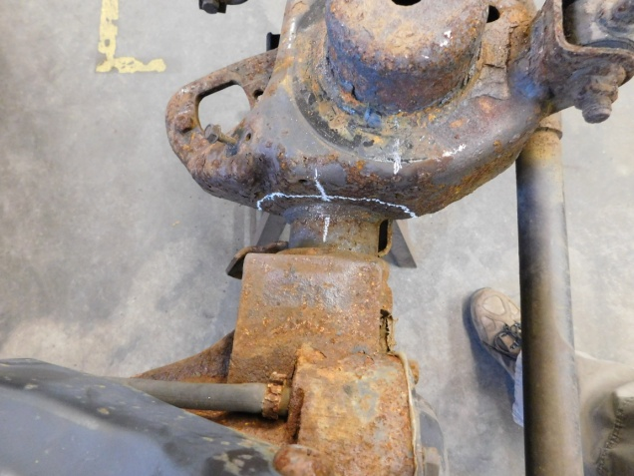

Cut away the original bracket using a plasma cutter, reciprocating saw or torch. Careful not to cut into axle!

Mark orientation of existing bracket on axle tube.

8

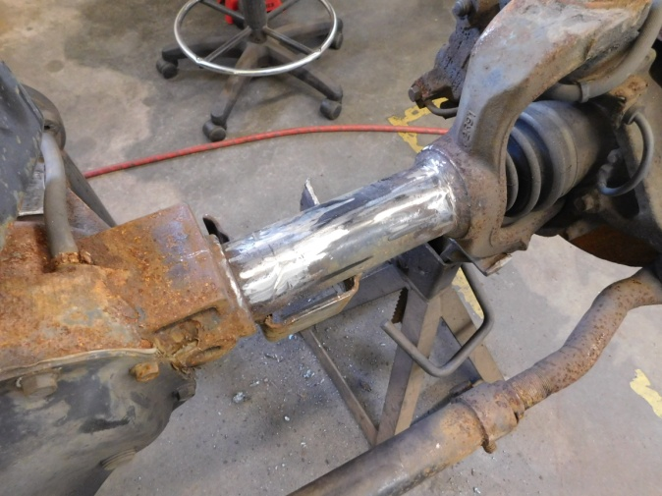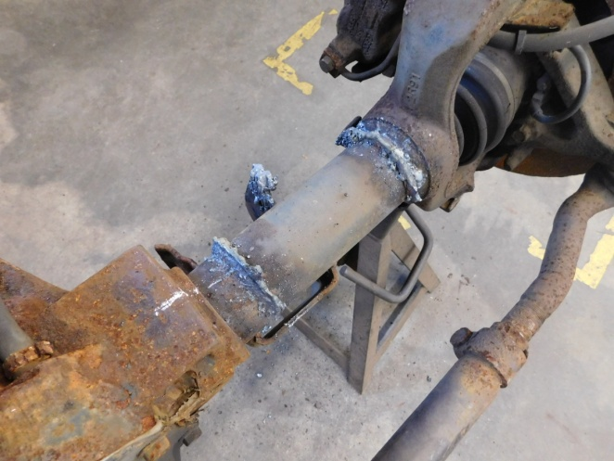

7

Grind axle down to clean metal where it will be welded.

Clean up remaining bracket material off axle tube. Leave locating marks.

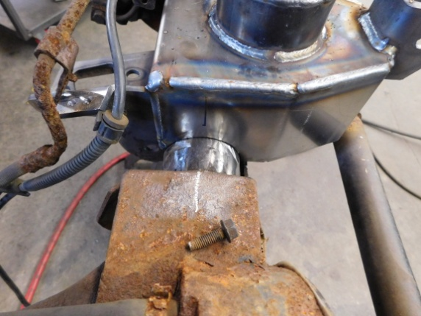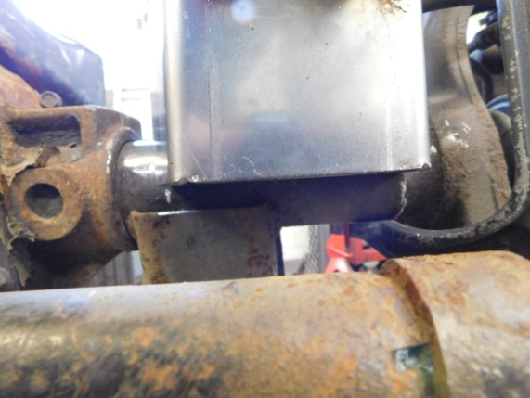

10

9

Position new bracket on axle using the locating marks made earlier.

12

11

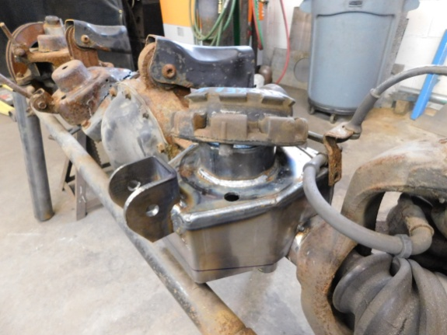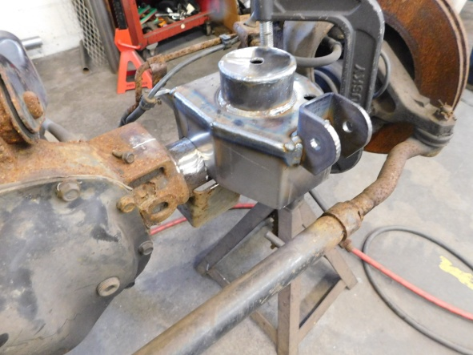

Install coil spring rubber bushing noting orientation of original locating hole.

Install coil spring, shock, sway bar & track bar.

Weld bracket to axle tube all around. Weld small sections at a time to reduce heat input into axle tube.