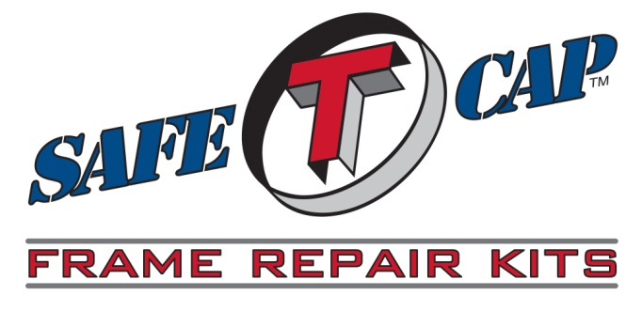

**1999-2006**

**Chevy Silverado**

**GMC Sierra**

**Cab Mount Installation**

**ART-178**

We Make it Easy to Make it Safe!

**800-407-7024**

**Installation Instructions ­­­­­­­­**

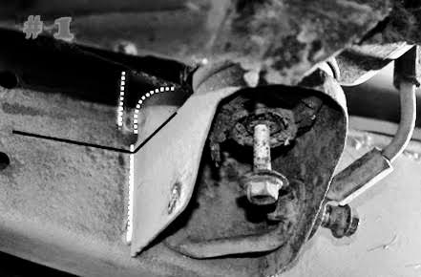

**IMPORTANT: Read and understand the instruction**

**For installing SafeTCap frame repair kits before**

**you begin. If you’re installing more than one cab**

**mount do one side at a time.**

**Jack up one side of the vehicle and use 2 jack stands to support it safely. Lift the cab slightly by placing a jack on the floor support channel. This will take pressure off the cab mount bushings.**

**Remove any ground cables, brake lines, and brackets from the mount, then mark the center of the mount by extending a location line from the center of the mount down the outside face of the frame, also mark the height of the bushing perch. SEE PIC #1**

**Remove the old cab mount as close to the frame as possible without cutting into the frame. See Yellow cut lines on PIC #1.**

**Grind any excess cab mount off the frame, then grind the area where the new cab mount will be welded making sure to remove all original coating or paint from the frame.**

**SEE PIC #2**

**Make sure not to remove the location lines you marked earlier, remark if necessary.**

**It is a good idea to prime/paint at least the top of your new SafeTCap cab mount before installing it on your vehicle as it will be more difficult once it is installed.**

**Clamp your new SafeTCap cab mount to your frame using the location lines marked earlier, install your cab mount bushings and hand tighten the cab mount bolt to the cab ensuring the mount and bushings are lined up properly. SEE PIC #3**

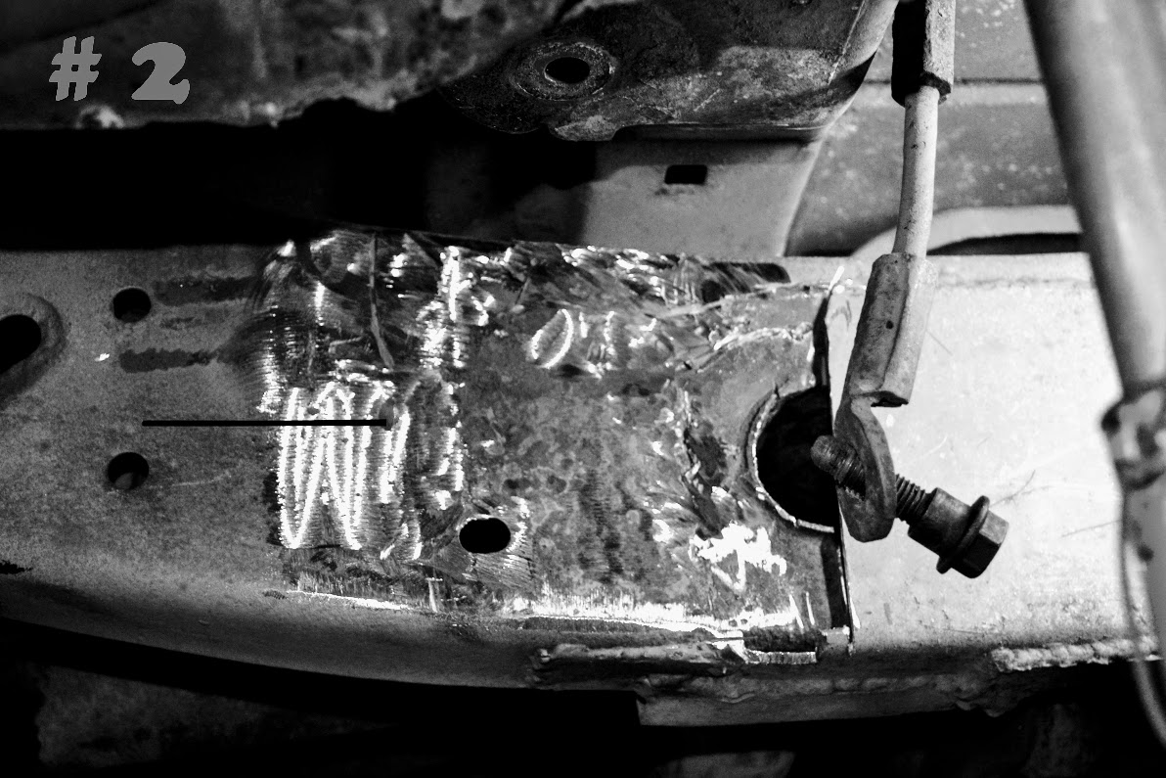

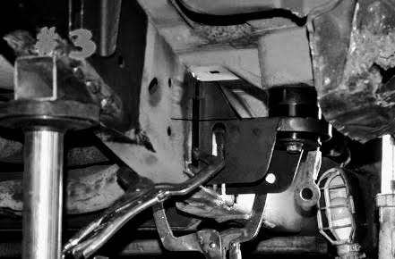





**1999-2006**

**Chevy Silverado**

**GMC Sierra**

**Cab Mount Installation**

**ART-178**

We Make it Easy to Make it Safe

**800-407-7024**

**Installation Instructions ­­­­­­­­**

**Once your cab mount is in the proper position Tack weld the new cab mount to the frame. SEE PIC #4**

**Remove cab mount bushings and weld your cab mount to the frame. SEE PIC # 5**

**After cab mount is completely welded install your cab mount bushings and reattach any brackets, brake lines and ground cables.**

**Cover any bare steel by priming/painting and / or undercoating you cab mount and frame. SEE PIC # 6**

**Remove jack from floor support channel and then remove the jack stands from under the frame and lower the vehicle to the ground.**

We Make it Easy to Make it Safe!

