**Installation Instructions**

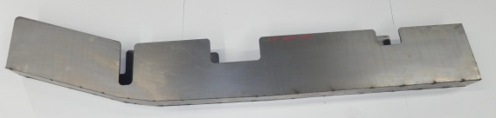**IMPORTANT: Read and understand the**

**“General Instructions for Installing SafeTCap**

**Frame Repair Kits” before you begin.**

1

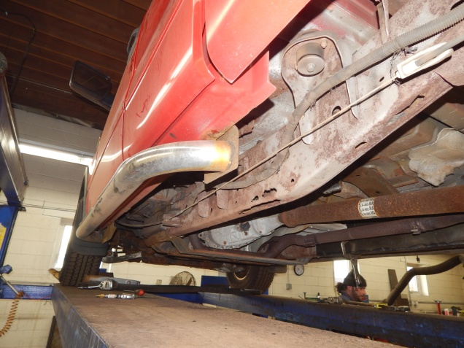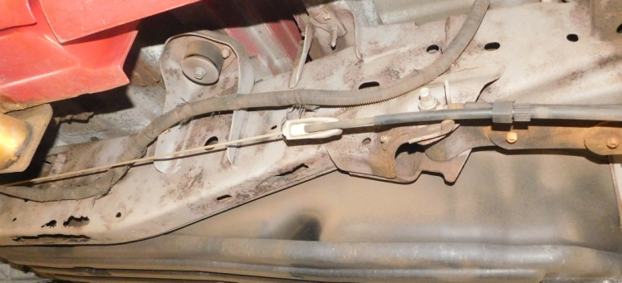

2

Jack up and support the repair side of vehicle leaving the area between tires clear.

**Figure A**

Remove any brackets or line clamps for access to repair area.

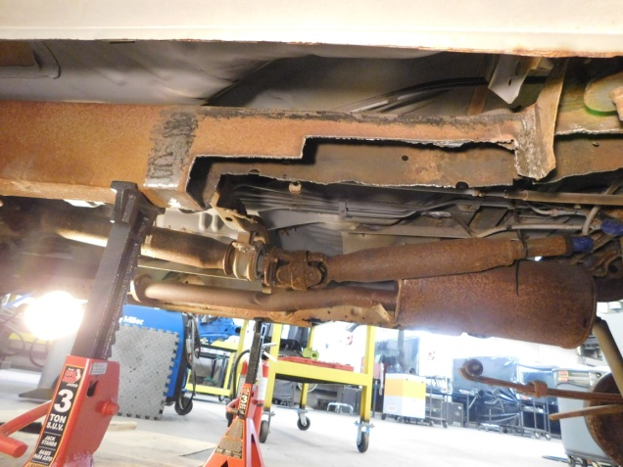

4

3

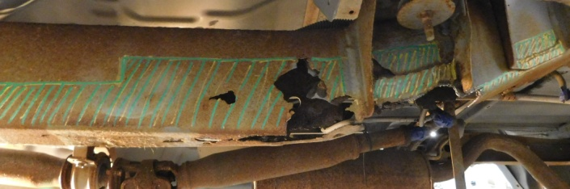

4

Mark areas to be cut away.

Cut out marked areas and grind surrounding areas clean to prepare for welding.

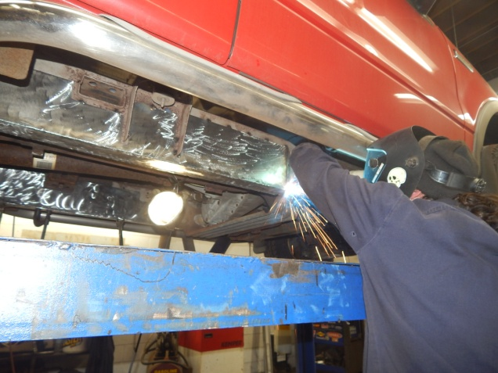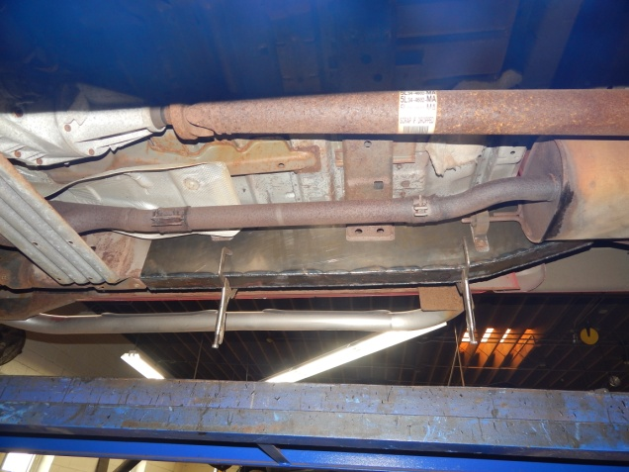

6

5

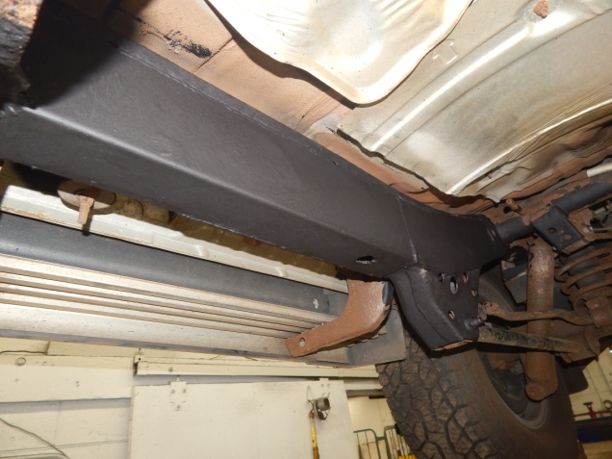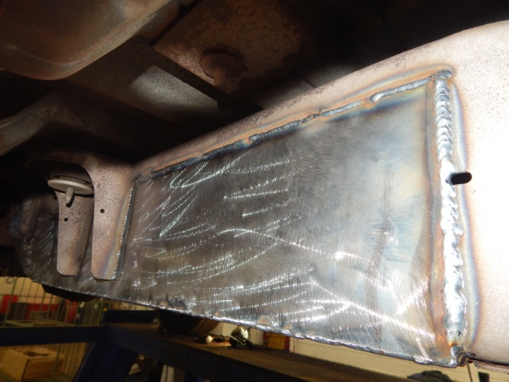

Weld solid all around the new part. Re-attach any brackets that were cut off.

7

8

Coat repair area with paint or undercoating.

Double-check positioning and tack weld in place.

Install new Safe T Cap and clamp in place.

8