Installation Instructions
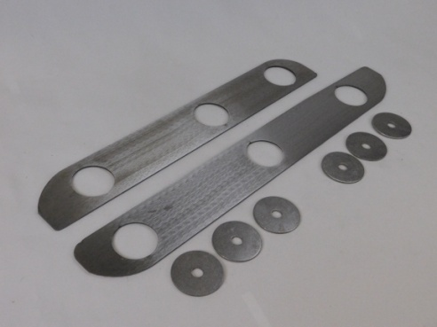
- IMPORTANT: Read and understand the “General Instructions for Installing SafeTCap Frame Repair Kits” before you begin.
- You can either do this repair on the vehicle or remove the skid plate.
- If removing the skid plate, jack up rear of vehicle and support it with appropriately rated jack stands.
ART-175 shown
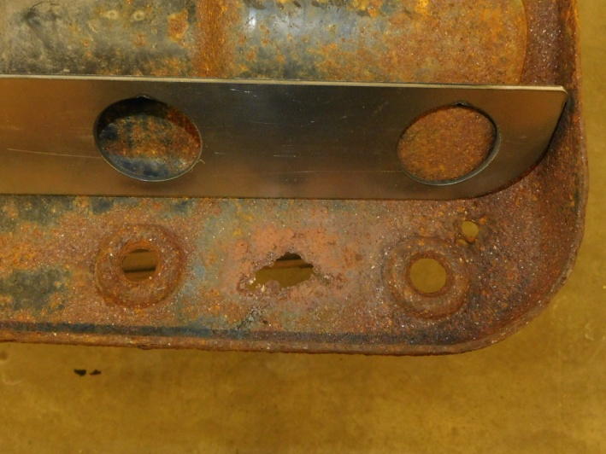
- Support rear of transmission and unbolt the transmission mount from skid plate, then unbolt skid plate from frame.
- Temporarily fit the skid plate repair plates to skid plate and trace around them to mark where to grind the metal clean. (see Figure A)
- Grind skid plate down to bare metal for a good weld.
- Fit repair plates on skid plate and weld in place.
Rust issues in skid plates
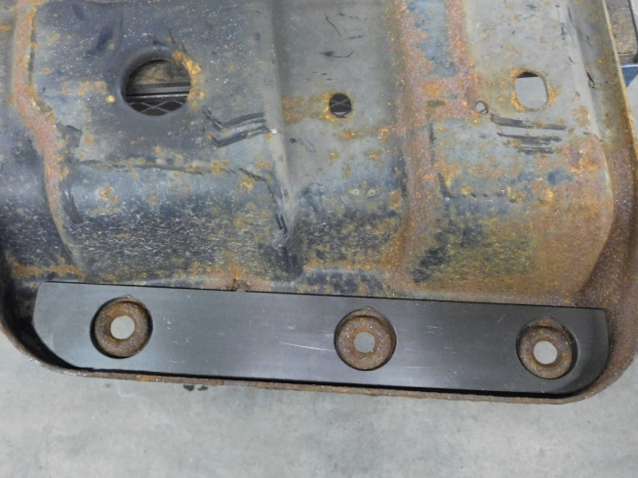
- Prime and paint or undercoat repair areas.
- Fit skid plate back up under frame and use the flat washers included with the original bolts to loosely hold in place.
- Bolt the transmission mount to skid plate. Make sure the driveshaft is perpendicular to rear axle. Tighten transmission mount bolts.
- Tighten skid plate to frame bolts until washers dimple slightly.
Figure A
- Recheck all nuts and bolts.

