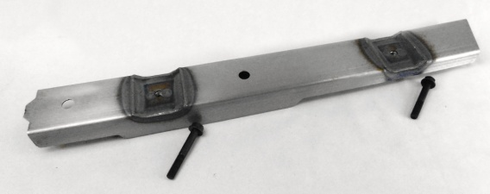**Installation Instructions**

**IMPORTANT: Read and understand the**

**“General Instructions for Installing SafeTCap**

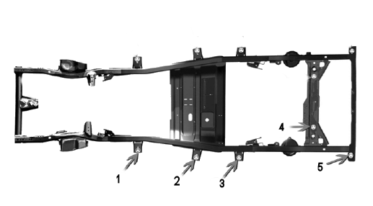 **Frame Repair Kits” before you begin.**

1

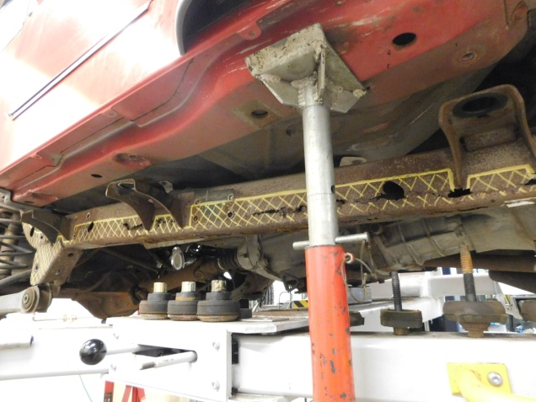

2

Remove the five body mounts shown on repair side for access to repair area.

**Figure A**

Lift cab in front of repair area as shown and in rear near body mount high enough to remove body mounts.

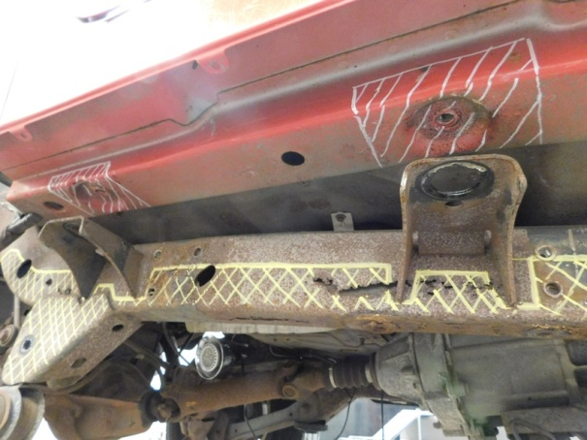

3

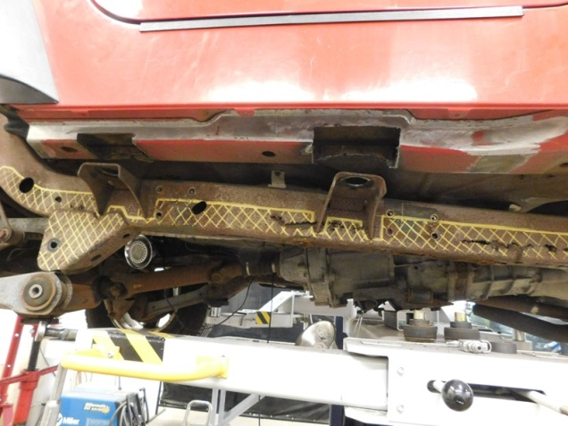

4

Mark areas to be cut away, giving enough room to allow for recessed area of new part to fit. Pull back floor carpeting above repair area.

Cut out marked areas and grind surrounding areas clean to prepare for welding.

5

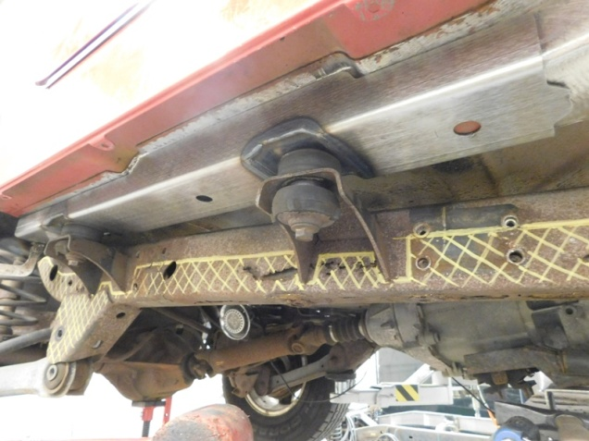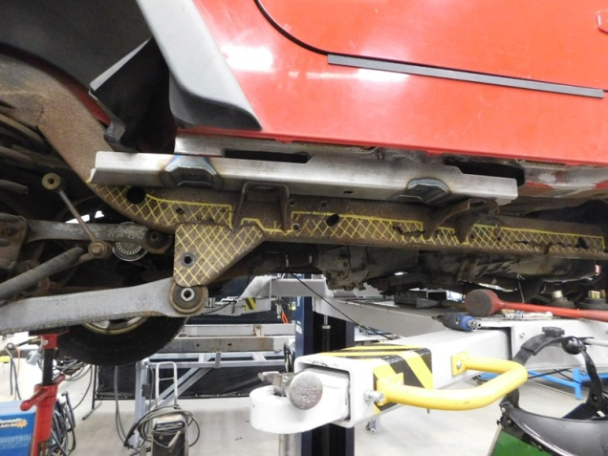

6

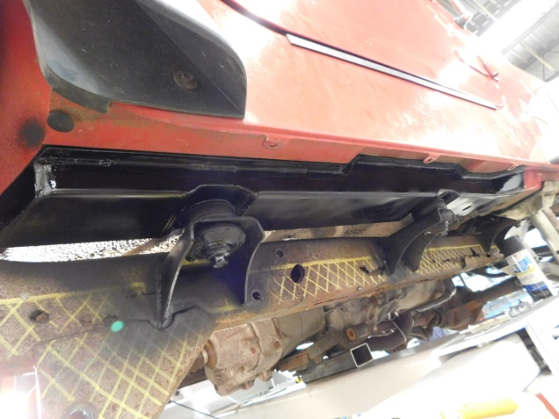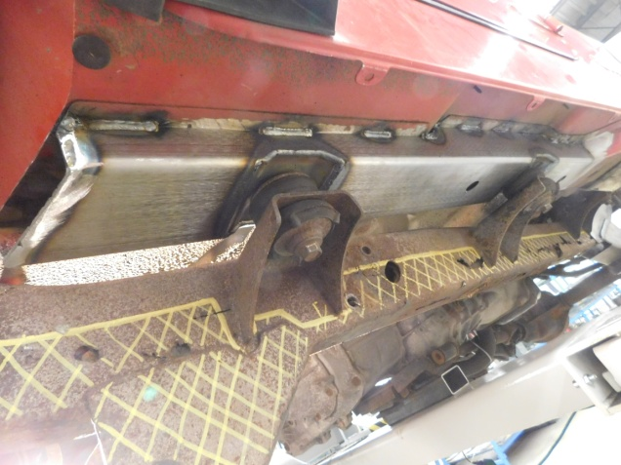

Seal seams with body seam sealer & paint. Reinstall all body mounts & torque to 50 ft-lbs.

8

Remove body mounts & stitch weld into place as shown.

7

Temporarily install body mounts & lower cab onto frame to check fitment.

Slide new part in from rear as shown.