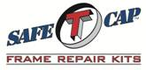
ART-122 1987-1995 Wrangler YJ Rear
Upper Shock Mount Frame Repair
www.SafeTCap.com
1-800-407-7024
Installation Instructions 2/5/2018

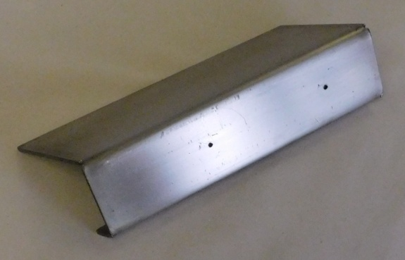
- IMPORTANT: Read and understand the “General Instructions for Installing SafeTCap Frame Repair Kits” before you begin.
- Chock tires and jack the rear of your Jeep high enough to create a safe work space. Use quality jack stands for support.
- Remove tire on side you are working.
- Remove the shock.
- Take measurements & mark shock centerline on frame in area not to be ground clean to relocate the ART-122 & shock mount when reassembling.
- Use a plasma torch, oxyacetylene cutting torch, Sawzall, or cutting disc. Remove the shock mount.
- Place the ART-122 in position (see illustration A) and trace it on the frame.
- Grind the area to be welded down to clean metal.
- If you have purchased a new ART-123 SHOCK MOUNT with the ART-122 FRAME REPAIR we suggest you place the ART-123 on ART-122 using the two location holes & mark the shock centerline on ART-122. (see illustration B)
- If using the original shock mount or another manufacturers shock mount, you will have to position it using the location measurements from step 5 after welding the ART-122 to the frame.

ART-122 1987-1995 Wrangler YJ Rear
Upper Shock Mount Frame Repair

- Place the ART-122 on the frame, use measurements & marks from step 5 (illustration A), tack weld it in place.
- Place the shock mount in position and test fit the shock.
- If satisfied with fit remove shock and weld ART-122 and shock mount solid.
- Paint or coat repair.
- Install shock.
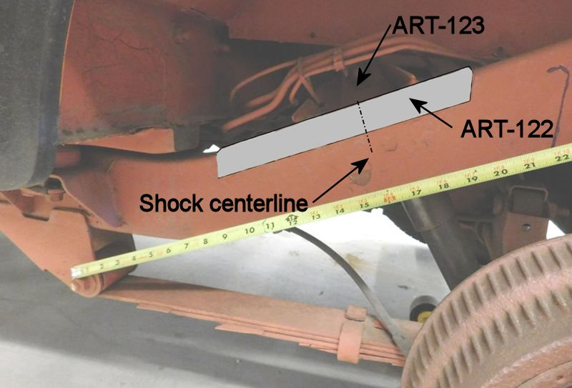
- Recheck all nuts and bolts.
Illustration A

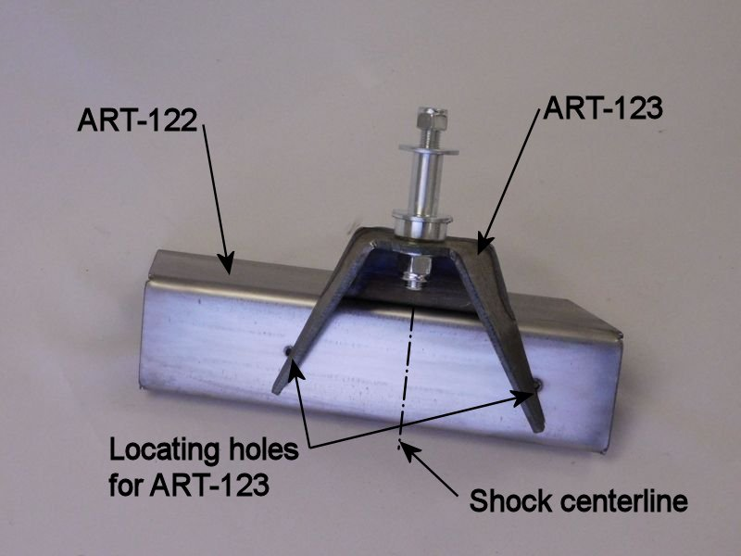

Illustration B

