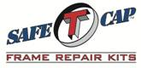
ART-112
1987-1995 Wrangler YJ
Forward Fuel Tank
Support Cross member
www.SafeTCap.com
1-800-407-7024
Installation Instructions 1/29/2018
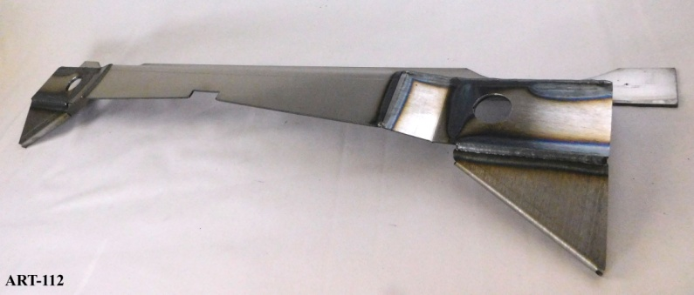
- IMPORTANT: Read and understand the “General Instructions for Installing SafeTCap Frame Repair Kits” before you begin.
- Run the fuel level down in the tank to facilitate removal.
- Inspect mount bolts and rubber mounts, order new from dealer ahead of installation.
- Chock front wheels and jack up the rear of the vehicle and support on jack stands.
- Remove rear wheels.
- Remove rear bumper.
- Disconnect the fuel lines and move them far enough out of the way to avoid fire by sparks, the electrical for fuel pump, and filler neck assembly.
- Remove fuel tank skid plate.
- Remove fuel tank.
- Take reference measurements from a reliable point on frame such as leaf spring mount to damaged crossmember for positioning of new part later.
- Remove the four rear body mount bolts. (two at cross member, two at rear bumper) Jack the body up off frame. It may be necessary to loosen or remove the four mid-frame body mounts to raise the body off frame high enough to slide new part in.
- Cut old cross member as close to the frame as possible without damaging the frame itself and remove.

Continued…

- Grind remaining cross member flush to inside of frame.
Clean frame to bare metal where new part is to be welded.
- Install OEM body mounts in new cross member. (ART-112)
- Align body mount holes in new cross member with mounting holes in the tub body.
- Install body mount bolts through ART-112 into mounting holes in the tub body.
- Tighten body mount bolts in cross member, this will draw the cross member into position for welding. A hammer may be used to ensure the cross member is all the way up and in place. Double check position using the reference dimensions taken earlier.
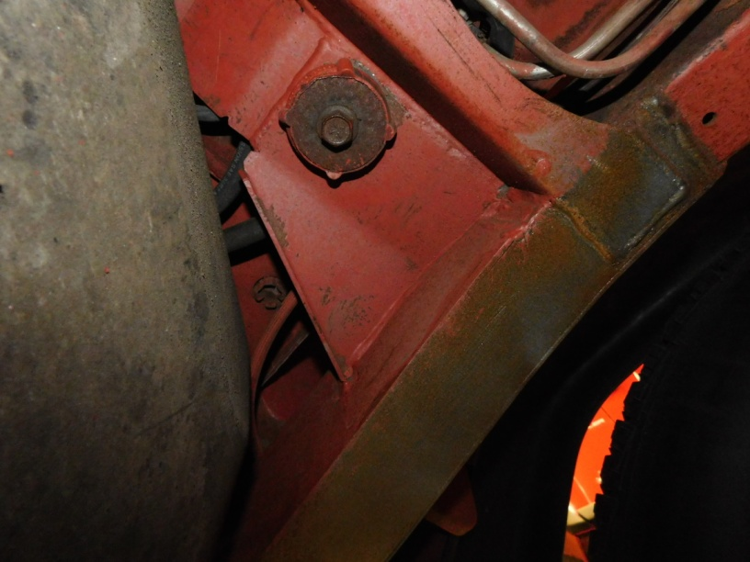
- Weld cross member into place.
- Inspect welds, and then apply paint or undercoating to protect the new frame components.

