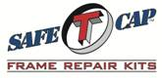
ART-099 1987-1995 Wrangler YJ Center Frame at Skid Plate Mount
www.SafeTCap.com
1-800-407-7024
Installation Instructions 1/29/2018
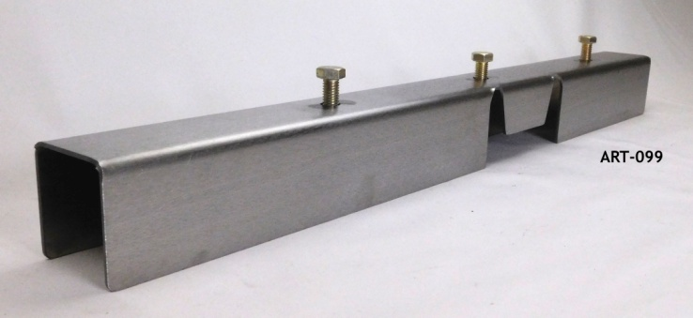
- IMPORTANT: Read and understand the “General Instructions for Installing SafeTCap Frame Repair Kits” before you begin.
- Jack up all four corners of your Jeep and support the front and back ends safely on four quality jack stands., give yourself plenty of clearance and work space.
- Unbolt and remove the skid plate, place a jack stand under the transfer case to support it.
- Cut the rear brake cable brackets off the backside of the frame on the drivers’ side only.
- Mark the area to be cut from the frame, leave a 1” overlap. [Illustration A]
- Transfer marks from one of the original bolt hole locations to the frame above where you will be cutting, mark all three holes for accuracy. [Illustration A]
- Cut and remove the rusted area, you can use a plasma cutter, sawzall, disc cutter or torch.
- Place the kit into position and roughly mark the area where you will be welding.
- Grind the areas clean that you have just marked, be thorough, a clean surface produces better welds.
- Slide the ART-099 over the frame and line up your center marks with the mounting holes in the frame kit.
- Use clamps and check to make sure the kit is in the correct location.
- Once you have verified the location is correct, weld 1” long beads around the ART-099 perimeter, then weld solid.
- Reattach brake cable brackets.
- Paint or undercoat the repair and new frame components.
- Bolt the skid plate & transmission back in place, lower the jack from the transfer case.
- Double check that all your welds are solid.
- Double check the skid plate bolts and transmission mounts are bolted tightly in place.
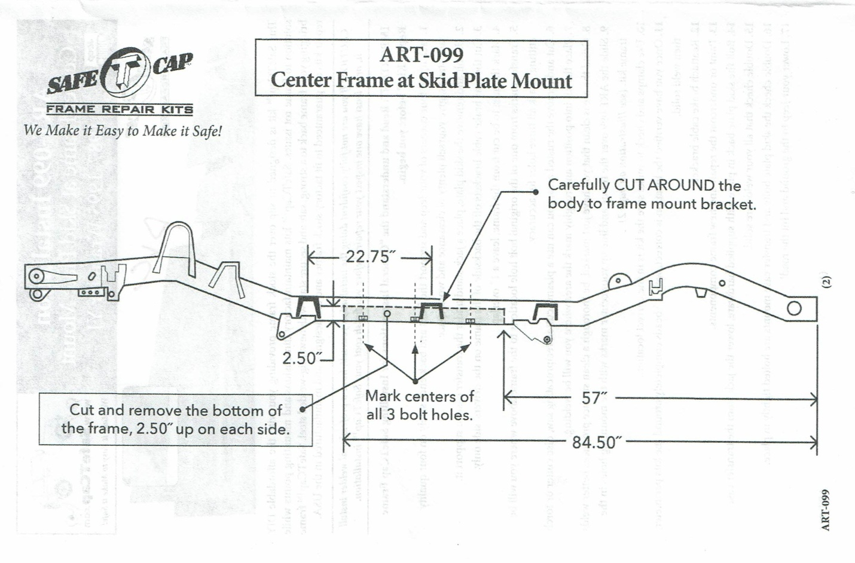
- Lower your Jeep to the ground and hit the road!
Illustration A

